
SOUTHERN WHITE CEDAR

By C.F. KORSTIAN, formerly Senior Silviculturist, Appalachian Forest Experiment Station, and
W. D. BRUSH, Scientific Assistant, Branch of Research, Forest Service

_________

CONTENTS

Page Page
Characteristics, growth, and management of Characteristics, growth, and management
the forest ---------------------------------------------- 1 of the forest-Continued.
Distribution and occurrence------------------------ 1 Management of southern white cedar------- 26
The tree ------------------------------------------ 5 Land utilization ------------------------------ 26
Form and development------------------------- 5 Treatment of stands---------------------------- 26
Leaves ------------------------------------------ 6 Best time to harvest the timber crop-------- 32
Flowers ----------------------------------------- 7 Financial returns------------------------------ 33
Cones ------------------------------------------ 8 Economic importance, physical character-
Seeds -------- -------------------------------- 9 istics, and utilization of the wood ------------- 36
Roots ----------------------------------------- 9 Economic importance-------------------------- 36
Bark ----------------------------------------- 9 Physical characteristics ----------------------- 38
Growth requirements ----------------------------- 9 Structure----------------------------------- 38
Climate --------------------------------------- 9 Physical and mechanical properties---- 39
Soil and soil moisture------------------- ---- 10 Durability ------- -------------------------- 42
Light --------------------------------------- 11 Utilization -------------------------------------- 43
Susceptibility to injury ------------------------- 11 Lumber ------------------------------------- 43
Fire --------- --------------------------------- 12 Shingles ------------------------------------- 45
Disease and decay -------------------------- 13 Lath ----------------------------------------- 46
Insects --------------------------------------- 15 Woodenware -------------------------------- 47
Wind ---------------------------------------- 15 Poles, shores, and spars----- -------------- 47
Natural reproduction ------------------------- 16 Small poles, posts, and stakes---- ------- 50
Seed production and dissemination ---- 16 Other uses------- --------------------------- 52
Estal5lishment of seedlings -------------- 16 Appendix -------------------------------------- --- 53
Influence of competing vegetation -- --- 17 Yield tables------------ ----------------------- 53
Influence of logging slash ---------------- 17 The southern white cedar alinement--
Influence of slash fires------------------- 18 chart stand table------------------------ 65
Growth and development of the stand -- --- 19 Volume tables--------------------------------- 67
Yields ------------------------------------------- 23 Taper and form tables----------------------- 71
Literature cited ----------------------------------- 75

CHARACTERISTICS, GROWTH, AND MANAGEMENT OF THE

FOREST
By C.F KORSTIAN ¹

DISTRIBUTION AND OCCURRENCE
Southern white cedar (Chamaecyparis thyoides), known also as white cedar, juniper, swamp cedar, and post cedar, is a valuable timber tree of the Atlantic and Gulf coastal swamps and estuaries. Its botanical range extends over the Atlantic coastal plain from
——————————————————————————————————————————————————————————
¹ In the conduct of the field work upon which the major portion of the first part of the bulletin is based the writer received valuable assistance from J. S. Holmes, State forester of North Carolina, Alfred Akerman, formerly district forester of Virginia, A. D. LaMonte, formerly assistant forester of New Jersey, and W. R. Hine, formerly assistant silviculturist, Southern Forest Experiment Station. Assistant Silviculturists L. H. Reineke and R. M. Brown, of the Forest Service, assisted in preparing the volume, taper, and yield tables. Additional data for the yield tables were contributed by former Associate State Forester W. M. Baker ,of New Jersey and District Forest Warden Lincoln Crowell, of Massachusetts. Sections in the first part were contributed by the following specialists: Diseases, by J. R. Weir, formerly Forest Pathologist, Office of Forest Pathology, Bureau of Plant Industry; Insect Injury, by the Division of Forest Insects, Bureau of Entomology. The Richmond Cedar Works, the Camp Manufacturing Co., and other owners and operators of southern white cedar assisted in various ways.

TECHNICAL BULLETIN 251, U. S. DEPT. OF AGRICULTURE 2

southern Maine to northern Florida and thence westward along the Gulf coast to the Pearl River Valley in southern Mississippi and eastern Louisiana. (Fig. 1.) Locally, the species is confined to fresh
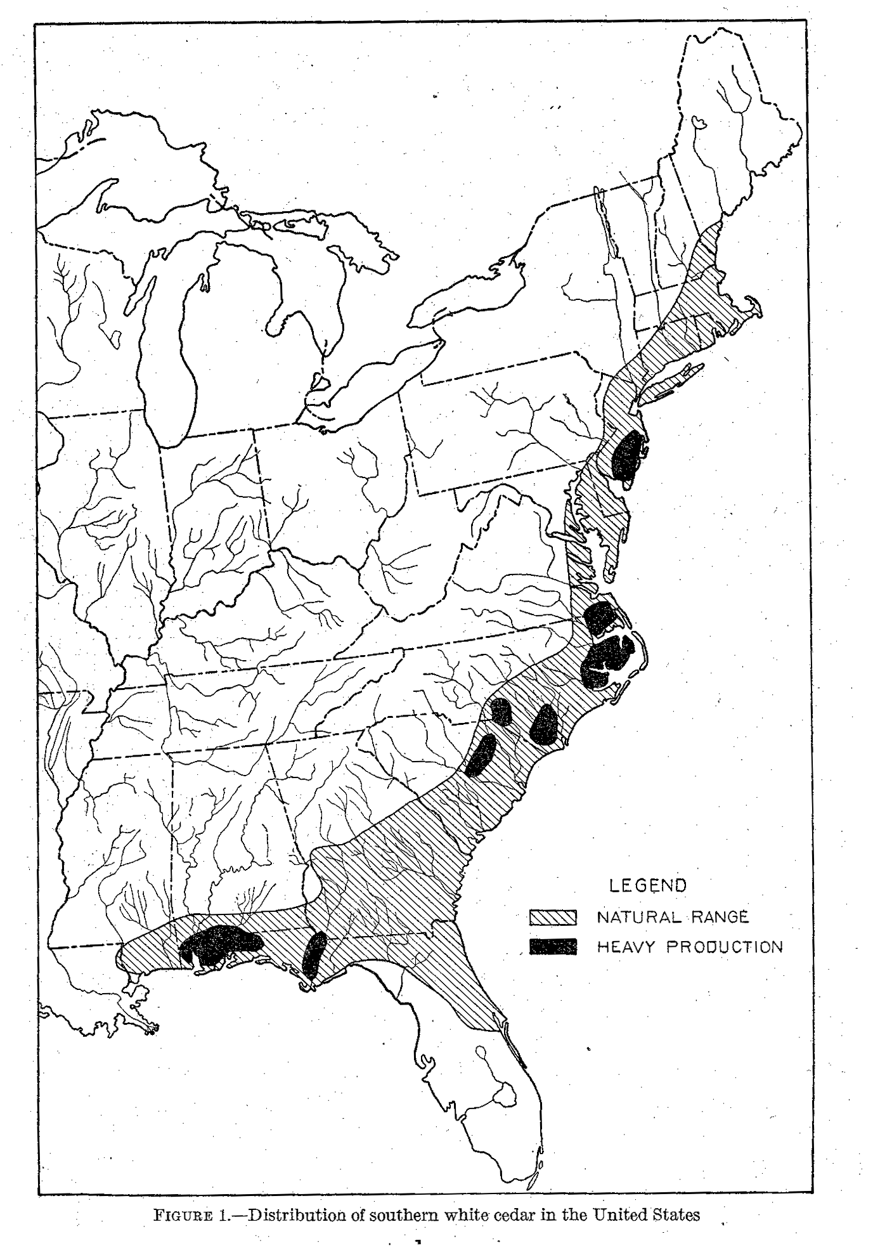

interior and river swamps, wet depressions, and stream banks. It is found in many detached tracts along a coast line of more than 2,600 miles.

SOUTHERN WHITE CEDAR 3

The commercial range of southern white cedar is very much more restricted than the botanical range. The heaviest commercial stands occurred originally in Virginia and North Carolina, especially in the Dismal Swamp and swamps draining into Albemarle and Pamlico Sounds. Other regions of relatively heavy production centered in southeastern New Jersey and in the vicinity of Mobile Bay and the Perdido, Escambia, and Apalachicola Rivers in Alabama and Florida.
The coastal swamps of the South Atlantic States are being combed repeatedly for southern white cedar trees suitable for poles. In the Dismal Swamp in North Carolina and Virginia, where once were some of the best second-growth stands of this species, the greater
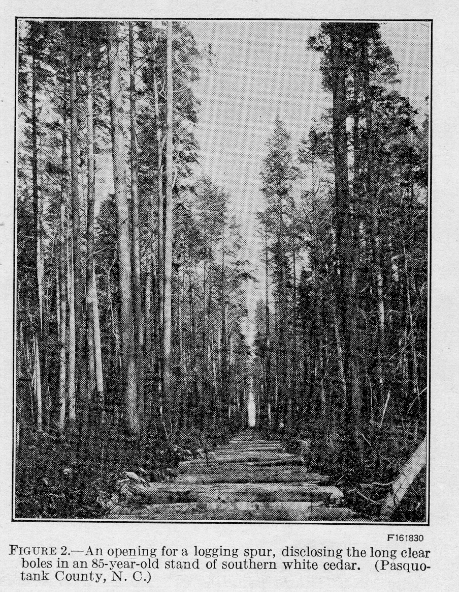
part of the merchantable
timber has been cut on
about 100,000 acres of
cedar land. Much the
same condition exists in
the Albemarle Sound re-
gion of North Carolina.
In New Jersey and
Connecticut also most
of the merchantable
stands have been cut.
Utilization has been
very close in New Jersey,
where there are many
uses for smaller mate-
rial. Here, as in the
Dismal Swamp region,
it is common to find
several classes of prod-
ucts being cut from the
same area, almost as
soon as the trees be-
come merchantable.
Three features of the
growth of southern
white cedar largely
responsible for
its past and present
commercial importance
and which at the same time add much to its value for forestry and to the ease with which it may be managed are as follows: (1) Its pronounced tendency to grow in pure stands (fig. 2); (2) the density of these stands (fig. 3); and (3) the fact that these stands are generally even aged, except occasionally where small trees were left in previous cuttings and 2-aged stands have resulted. Throughout the greater part of its range the natural stands of southern white cedar are generally pure, even aged, and dense. Pure stands, frequently called "juniper glades" or "cedar glades," once covered a much larger area than they now do. Such stands occur on areas of swamp peat overlying a sandy subsoil; but as the quantity of silt and clay in the underlying subsoil increases, the proportion of swamp hardwoods
TECHNICAL BULLETIN 251, U. S. DEPT. OF AGRICULTURE 4

increases until the southern white cedar can no longer compete with them.
Mixed stands are generally the result of fire in a juniper glade. In the South Atlantic
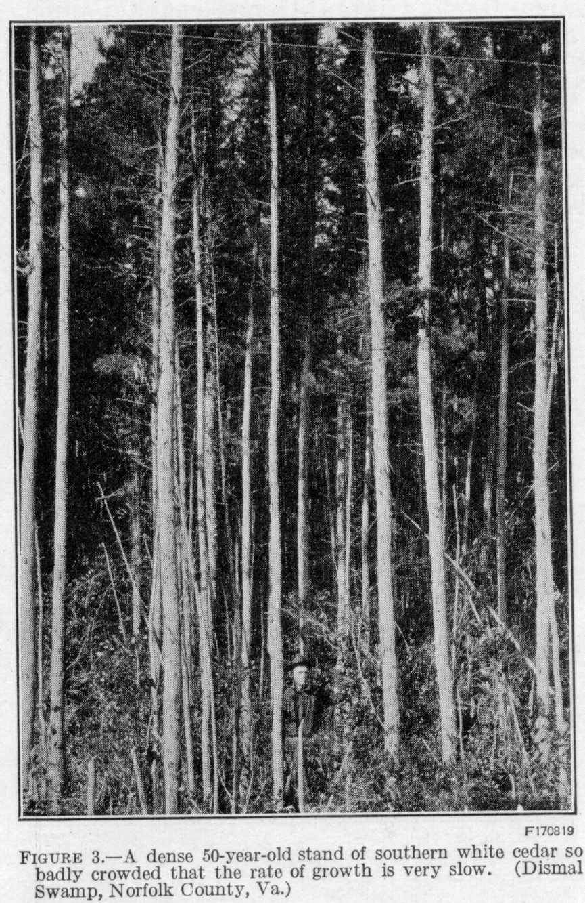
and Gulf States there
has been an increase
in mixed stands result-
ing from the culling
over of pure stands
for poles. After such
cullings some or all of
the cedar reproduction
which would other-
wise replace the trees
removed is eliminated
by the more rapid
growth of various other
species, mostly of in-
ferior value.
The extensive latitu-
dinal range of southern
white cedar brings it
into contact with a
large number of asso-
ciated tree species. The
number and diversity
of associates increase
as the climate become
s warmer and more humid
in the South Atlantic
and Gulf States. Some
characteristic associates
of southern white cedar,
together with the places
found, are as follows:

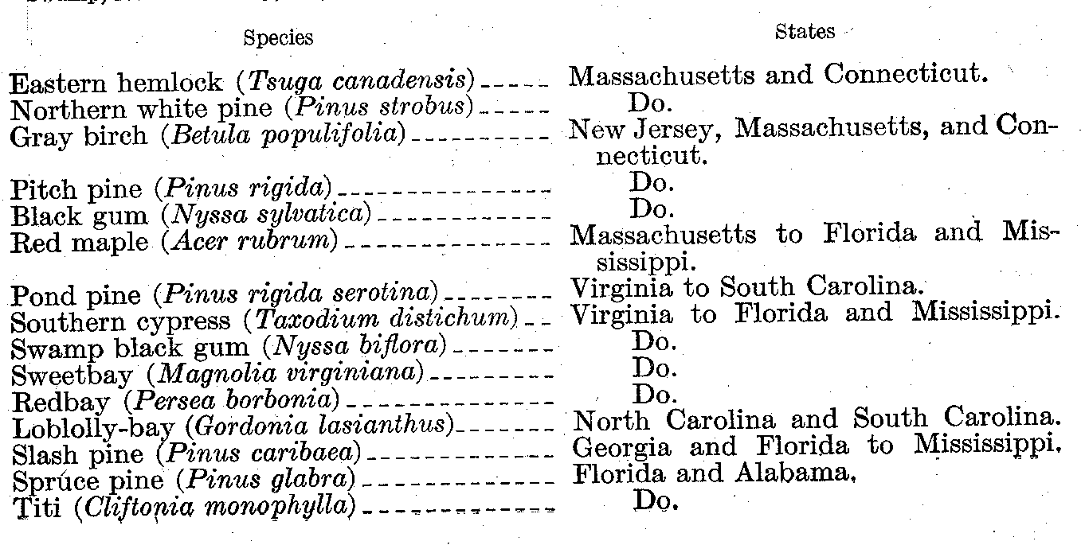
SOUTHERN WHITE CEDAR 5

On the more fertile muck or sandy loam swamp soils in eastern North Carolina, southern white cedar is sometimes associated with loblolly pine (Pinus taeda) and yellow poplar (Liriodendron tulipifera), along with the common swamp hardwoods. In such situations the cedar may form as much as half the stand, although here it tends to give way to these more aggressive competitors.
On good sites mature cedar stands of average density 75 to 100 years o1d contain trees ranging from 4 to 24 inches in diameter and averaging 10 to 14 inches. From 45 to 85 per cent of the trees are more than 10 to 14 inches. From 45 to 85 percent of the trees are more than 10 inches in diameter. The dominant trees in such stands vary from 70 to 100 feet and average about 80 or 85 feet in height. A height of 120 feet and a diameter of 5 feet have been reported. In the Dismal Swamp region and southward most of the southern white cedar lands may be regarded as good sites, producing trees 50 to 70 feet tall in 50 years; from New Jersey northward the cedar lands are capable of producing trees 20 to 50 feet tall in the same time.
A dense understory where tangled vines and native shrubs make passage difficult is common in white cedar stands. (Fig. 4.) Where fire has, burned off the original stand, areas, locally called "lights;" occur, in which tangled shrubby undergrowth is present to the exclusion of tree growth. (Fig. 5.)

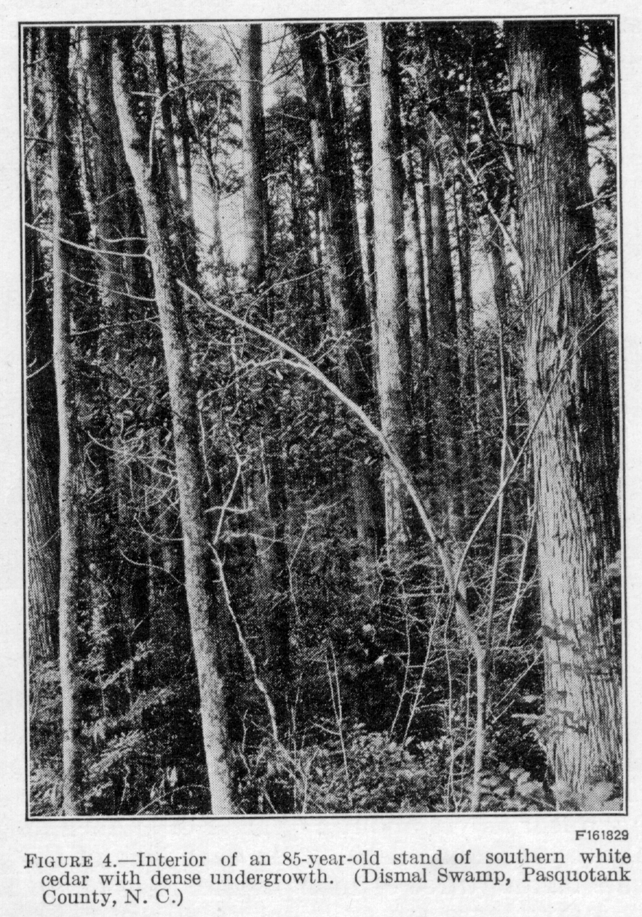
THE TREE FORM AND DEVELOPMENT

Southern white cedar is one of the most graceful and symmetrical conifers of eastern North America. The terminal shoots and branch tips lack the rigidity common to spruce, fir, and pine, and the crown is formed of slender, horizontal branches with somewhat pendent sprays of branchlets and twigs. The leader, or terminal shoot, often droops in the direction opposite from that of the prevailing wind.
In early life the tree has a conical stem, which later becomes less tapering, especially in closed stands having an unbroken crown canopy.
TECHNICAL BULLETIN 251, U.S. DEPT. OF AGRICULTURE 6

Mature southern white cedar grown in closed stands has a long, clear, straight bole and is an ideal tree for the saw. In dense stands the crown is very short, narrow, rather thin and conical in shape, commonly occupies only the upper one-fourth or one-fifth of the stem, and may be only l5 to 25 feet long by l0 to 20 feet wide. Crowding causes the bole to assume a more nearly cylindrical form below the crown and a very rapid taper within the crown. With increasing age, the crown gradually dies off at its base and finally becomes flattened and irregular.
Open-grown trees have greater taper and longer crowns. They are more limby and therefore have rougher boles than those grown in dense stands.

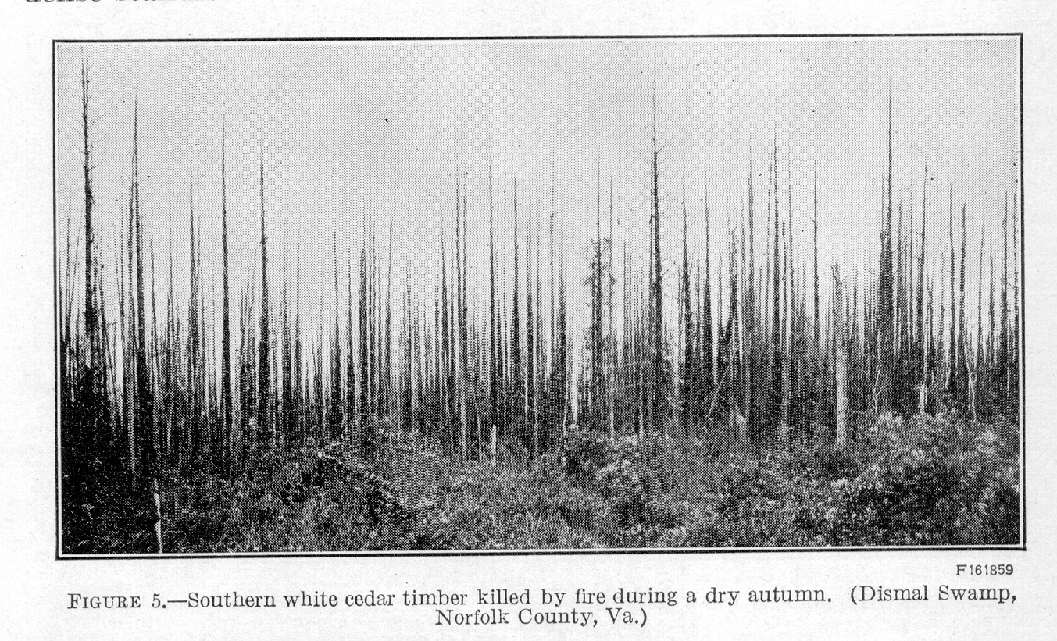

LEAVES

The two, or rarely three, seed leaves (cotyledons) are flat, linear, and rounded at the apex. (Fig. 6, A-C.) During the first year the primary stem is covered with rigid, sharp-pointed, horizontally spreading linear leaves about a quarter of an inch long (fig.6, F), light green above and marked below on each side of the prominent midrib with pale bands (three or four parallel rows of stomata). The awl-shaped primary leaves are produced singly, in pairs, or in distinct whorls of three to five leaves each; they usually wither by the end of the first or second season. The foliage on the branchlets of older stems consists mostly of secondary leaves, which are dull bluish green, scale like, ovate-pointed, awl-shaped, one-sixteenth to one-eight inch long, 4-ranked, and closely appressed against the flat branchlets or occurring on vigorous shoots and leaders spreading at the tips. (Fig. 7, C, Y.) They entirely cover the ends of the slender, drooping twigs. When exposed to the sun during the winter the secondary leaves and branchlets frequently become rusty brown. During the second season the leaves usually die and turn reddish brown, but they persist on the branch lets for many years.

SOUTHERN WHITE CEDAR 7

FLOWERS

The flowers appear early in the spring, usually in March or April at intermediate latitudes. The male and female flowers are produced separately, although on the same tree. The male or staminate flowers are oblong, 4-sided, and about one-eight inch long. (Fig. 7, H, 1.)

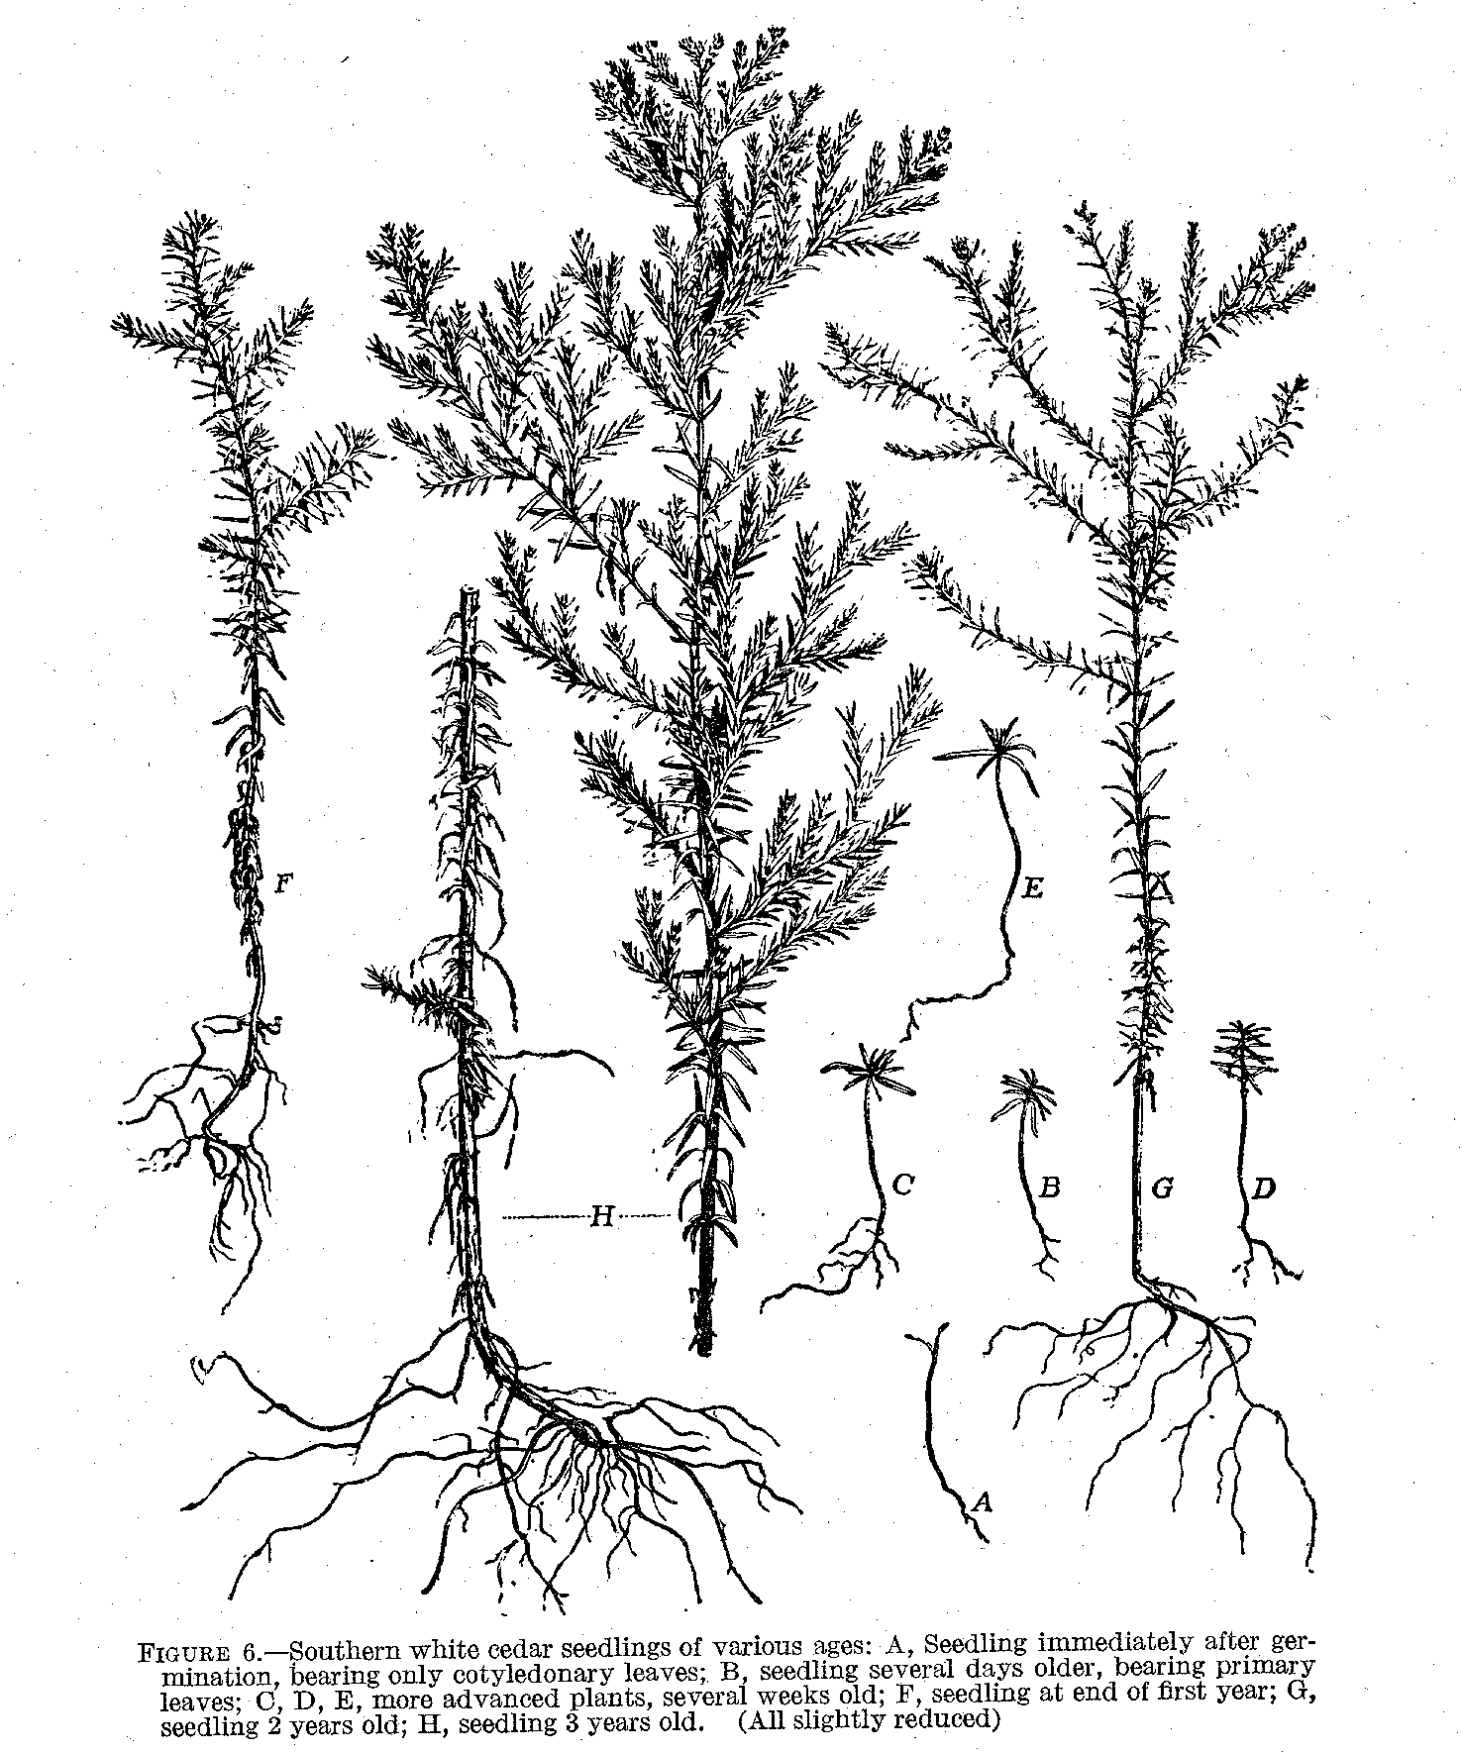

Each of the 10 to 21 stamens is provided with two pollen sacs. (Fig. 7,J-P.) The female or pistillate flowers are borne on the short lateral branchlets of terminal shoots. (Fig.7, A-C.) They are about one eighth inch in diameter and consist of three pairs of scales set at right angles. These scales are thinner and paler than the surrounding

TECHNICAL BULLETIN 251, U.S. DEPT. OF AGRICULTURE 8

leaves. Those of the uppermost pair are mostly sterile. The others bear two rounded, minute, flask like ovules on their upper or inner sides. (Fig. 7, D-G.)

CONES

The pistillate flower develops into the cone, or ripened fruit, by the end of the first season. The rather inconspicuous spherical cones, about one-quarter inch in diameter, are formed of five shield-shaped scales arranged in two pairs at right angles to each other, with a single

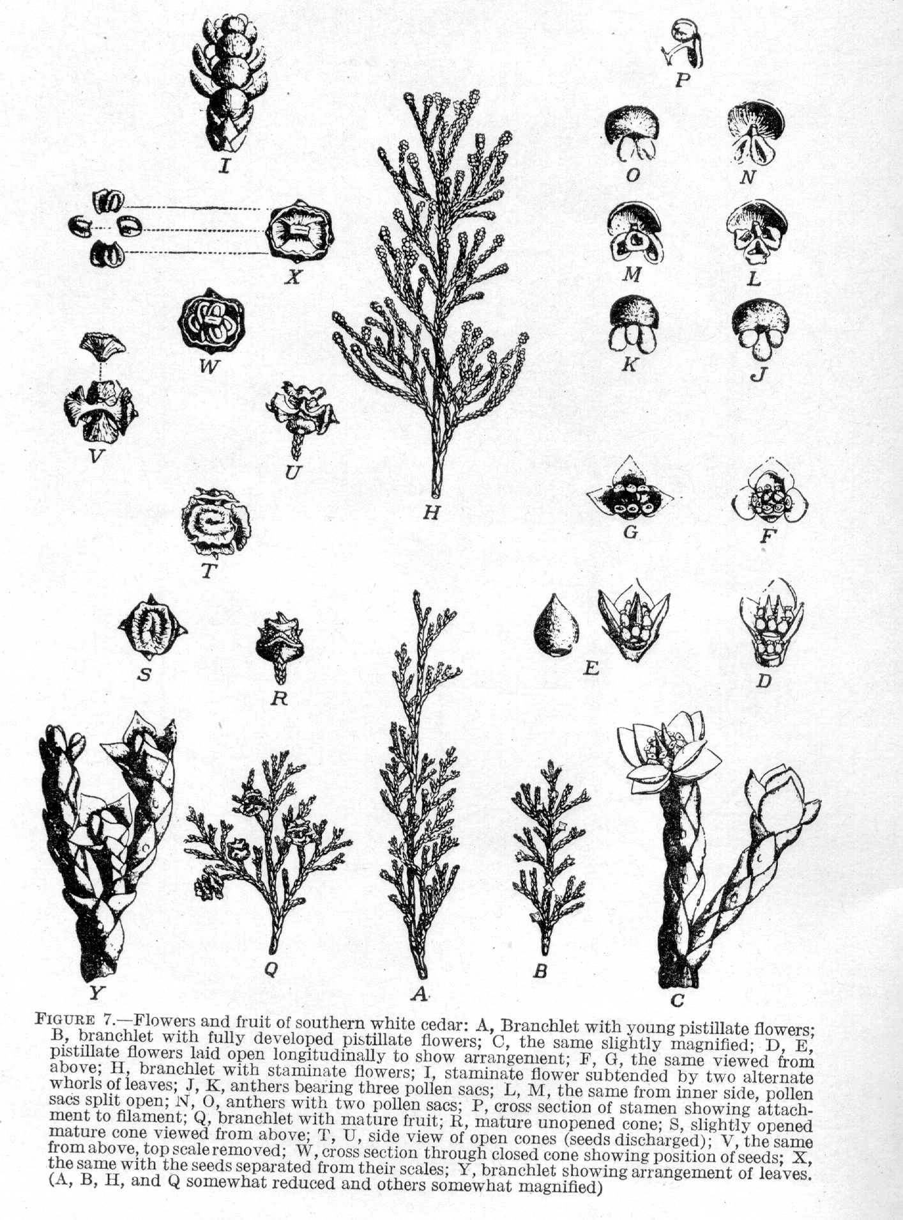
SOUTHERN WHITE CEDAR 9

scale in the middle. Occasionally cones are found with six scales. These scales are slightly rough and angular and the depressed center has a weak prickle. (Fig. 7,R-X.) The cones are light green and covered with a gray or bluish bloom while immature, changing to bluish purple, and finally dark reddish brown when ripe. They mature in one year and contain about 5 to 15 winged seeds, or an average of 10 seeds per cone, of which I to 3 are embedded in a groove at the base of each fertile scale. There are approximately 159,360 cones to the bushel, weighing 25 to 35 pounds, depending upon their dryness.

SEEDS

The seeds are rounded, slightly compressed, light brown, and about one-eighth inch long, bearing winged membranaceous margins about as broad as the seeds and darker in color, formed by the seed coats. There are between 420,000 and 500,000 clean, ripe seeds to the pound, the average of 11 separate determinations of seed from the Dismal Swamp region in North Carolina and Virginia being 460,000. The average weight per thousand is 0.96 gram (0.034 ounce). The percentage of germination is 70 to 90.

ROOTS

Southern white cedar has a shallow root system. In swamps where the lower soil layers are permanently saturated with water, the roots are confined chiefly to the upper I to 2 feet of peat. Where the water table occurs at lower levels and the soils are more deeply aerated, the roots often penetrate to greater depths.
The small taproot formed during the first year is subsequently lost in the development of the strong superficial lateral roots. (Fig. 6, F, G, H.) These are numerous but do not become large. They are covered with a thin, firm bark composed of a pale-red or reddish brown outer layer and a white inner layer.

BARK

The volume of bark varies from 35 per cent of the total volume in trees I inch d. b. h^{. 2} to 11 per cent in trees 24 inches in diameter. Although the bark is usually quite thin over the entire tree, in old mature trees, it may sometimes become 1 to 2 inches thick at the stump. The bark gradually decreases in thickness with increased height, until it is no more than 0.1 inch or so where the stem is 1 inch in diameter. The bark varies in color from ashy gray to light reddish brown on the outside and is usually bright cinnamon brown underneath. On small branches and young trees the bark is quite smooth, except that it may be slightly furrowed by long, shallow fissures. On older trees the bark is irregularly furrowed into narrow, flat, connected ridges separating into loose, elongated, plate like scales which easily peel off in long, tough, fibrous strips.

GROWTH REQUIREMENTS

CLIMATE

At some points in the wide range of southern white cedar the mean annual precipitation is as low as 40 inches and at others is as high as 60 inches. As a rule the precipitation is rather evenly distributed
———————————————————————————————————————————————————————
² D, b. b.-diameter at breast height, or 4 1/2 feet,

TECHNICAL BULLETIN 251, U. S. DEPT. OF AGRICULTURE 10

throughout the year, but in the southern part a peak of heavy rainfall occurs during July and August.
The humidity is generally high, owing to the proximity to the coast. The relative humidity commonly averages between 70 and 85 percent. Atmospheric humidity is apparently not essential for this species so long as the soil is abundantly supplied with water, but low humidity may be a limiting factor when soil moisture is deficient.
The great variation in temperature to which southern white cedar is subjected is shown by the records of the four widely separated United States Weather Bureau stations, presented in Table 1. Portland, Me., is near the northern limit of the species, and Pensacola, Fla., may be considered typical of the region of moderately heavy production, centering in Alabama and Florida. The southeastern New Jersey center of production is represented by the Tuckerton station, and Norfolk stands for the region in which the maximum yields have occurred. The wide variation between the midwinter (January) mean minimum temperature of 14.7º F. for Portland, Me., and the midsummer (July) mean maximum of 86.8º for Norfolk, Va., and Pensacola, Fla., is significant. Within its range the temperature, varies from a minimum of –25º at North Grosvenor Dale, Conn., to a maximum of 110º at Talbotton, Ga., a difference of 135º F.
The length of the growing season is indicated approximately by the period during which killing frosts do not occur. In southern Maine this period averages only 157 days; at Tuckerton, N.J., 169 days; at Norfolk, Va., 237 days; and at Pensacola, Fla., 286 days.

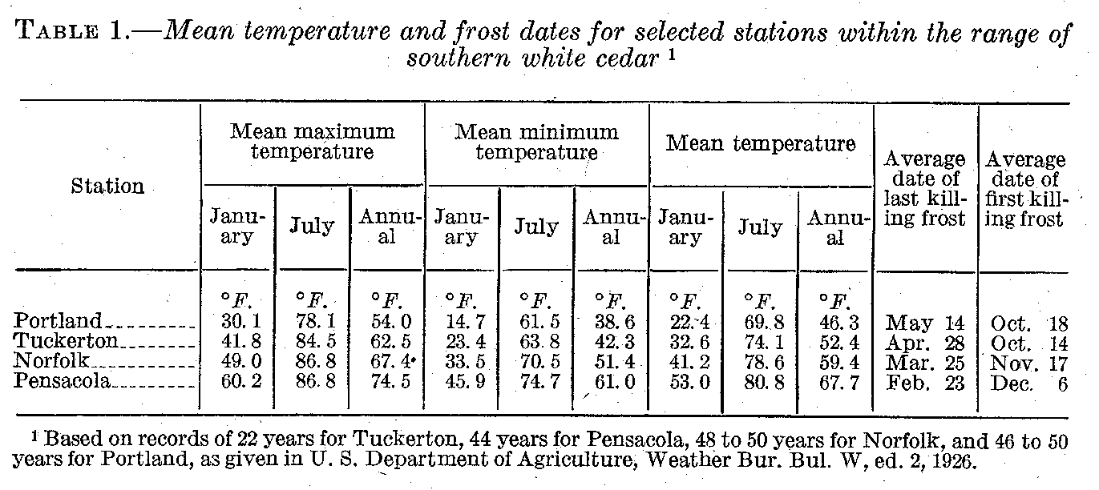

Southern white cedar in general requires a warm, equable, humid climate for its best development. These requirements are met in the peat swamps above tidewater bordering the South Atlantic and the Gulf seaboard, in which high temperatures, long growing seasons, and high atmospheric humidity’s prevail. The most aggressive competitors of the cedar also grow more rapidly in this region under the same combination of temperature and humidity.

SOIL AND SOIL MOISTURE

Southern white cedar is far more exacting in its site requirements than in its demands for beat or atmospheric humidity. Soil and soil moisture are the chief factors limiting the occurrence of this species within its natural range. It is strictly a swamp tree, and the limits of

SOUTHERN WHITE CEDAR 11

its occurrence usually coincide with the edges of fresh-water swamps, although a few short, scrubby trees are found on drier and more elevated lands. In the more inland parts of its range this species occurs along the sandy beds of small streams or the contiguous sandy flats subject to frequent overflow. Dense, pure stands are confined to areas of acid swamp peat overlying a sandy subsoil: The hardwood cypress swamps surrounding the cedar glades, especially those in the Dismal Swamp and Albemarle Sound regions of North Carolina, are underlain by a clay or sand-clay subsoil less acid than that of the cedar swamps. The proportion of swamp hardwoods in the cedar stands becomes greater as the amount of silt and clay in the underlying subsoil increases. Peat mosses (Sphagnum) are usually abundant in most of the wet cedar swamps. Although the water in both the cedar and hardwood swamps is acid, that of the former is fresh and usually drinkable, whereas that of the latter is often stagnant and polluted. Water ordinarily stands in the depressions of the cedar swamps for several consecutive months during the winter and spring. In unusually, dry seasons, particularly in the autumn, the water table may fall as much as 2 to 3 feet below the surface.
Although requiring much water, southern white cedar can yet withstand such dry periods successfully. On upland soils, where the tree has been occasionally planted as an ornamental, the much lower water supply is reflected in slower growth and less vigorous appearance. Natural reproduction in such situations generally fails to survive.

LIGHT

The species is very tolerant of shade, especially in early youth almost as much so as hemlock (Tsuga canadensis) and the balsam firs, (Abies balsamea and A. fraseri). However, it can not survive under the extremely heavy shade of a dense stand of older cedar (7, 11)³. 'The young trees will stand about as much shade as most of the associated hardwoods and much more than northern white pine, pitch pine, pond pine, slash pine, and southern cypress. Young cedar seedlings sometimes become established under the shade of swamp shrubs.
After the Juvenile stage is passed, the tree becomes more exacting in its demands for sunlight. This is evident from the absence of young trees among the undergrowth of closed stands and from the dying out of seedlings, suppressed trees, and the lower branches at an early age. The intense struggle for light is reflected in the rapid height growth of the young tree and the development of a slender, slightly tapering bole.

SUSCEPTIBILITY TO INJURY

In comparison with associated species, southern white cedar ranks high in resistance to injuries. It is susceptible to wind throw but is almost immune to insect attack. Parasitic diseases ordinarily cause only light losses, except where the bark has been removed from standing trees and rapid decay of the sapwood ensues. In southern New Jersey many trees have been ruined by fishermen who use strips of the tough bark on which to string their fish; and in the more remote swamps farther south bears have made decay possible by stripping the bark from the trees. (Fig.8, A.) Fire is by large the worst enemy.
——————————————————————————————————————————————
³ Italic numbers in parentheses refer to Literature Cited, p. 75.

TECHNICAL BULLETIN 251, U. S. DEPT. OF AGRICULTURE 12

FIRE

Because of its thin bark and highly inflammable leaves and twigs southern white cedar is at all ages very susceptible to fire. Fire scars on living trees are uncommon in this species, since most trees subjected to fire are killed. Even a very light fire is sufficient to kill the cambium (the layer of growing cells between the bark and the wood), and the trees thus girdled die. Many trees on the edges of cedar swamps are

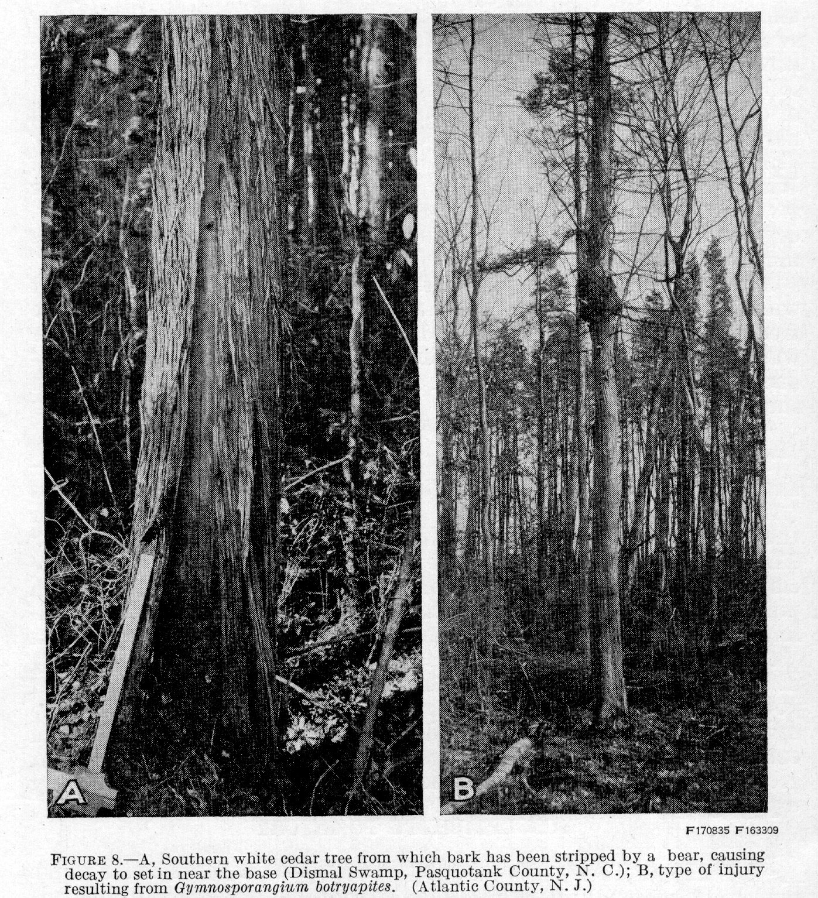

killed by fires coming from the outside, but in most cedar swamps the peat is so wet and the air within the forest so humid that fires seldom sweep through except during unusually dry seasons or when an unusually hot fire is driven by a strong wind. The larger trees are sometimes not killed outright but die gradually from the top down.
In dry seasons, when the peat becomes thoroughly dried, fires on adjacent pine, hardwood, or brush lands sometimes spread to the white cedar swamps and cause severe damage. Not only young growth but older stands may thus be destroyed and the peat burned down to the

SOUTHERN WHITE CEDAR 13

water table or the underlying soil. The most disastrous fires are generally those which burn in slash a few years after logging. These fires destroy large areas of young growth. They will be considered further under the heading Influence of Slash Fires on Natural Reproduction.
DISEASE AND DECAY ⁴

The fungi of importance in the management and utilization of southern white cedar may be considered in two main groups-those attacking the living tree and those attacking the wood after it is cut.

FUNGI OF THE LIVING TREE

The fungi of the first group may be divided into two classes, as follows: (1) Parasitic fungi, attacking the living parts of the tree and reducing the growth; and (2) cull fungi, attacking the heartwood and causing loss in the quantity and quality of merchantable timber. At present the direct loss in merchantable timber renders the cull fungi the more important.
Keithia chamaecyparissi Adams is intensely parasitic and is very destructive to the foliage of young trees and seedlings. In dense stands in the northern range of the tree, seedlings are killed and the foliage of the lower branches or of young trees may be entirely destroyed. The fungus is parasitic on the leaves, causing them to turn brown, then gray. This attack on the leaves ends with the death of the young twigs. The presence of this fungus in nurseries is to be expected. The fruiting bodies (perithecia) of the fungus are usually conspicuously kidney-shaped areas on the upper side of the leaf. They rupture from one side. Lophodermium juniperinum (Fr.) De Not. has a similar effect but is not so destructive. It appears to be infrequent and attacks the foliage only when it is in a constantly moist condition, as on the branches of young trees bent near the ground and on seedlings covered with forest debris. The fungus is inconspicuous but may be distinguished by the small-sized, black fruiting body which ruptures irregularly.
Asterina cypressina Cke. attacks the leaves of the older twigs, causing them to wither and die. The effects of this fungus have been studied in only a few cases, and hence its importance and the degree of its parasitism are at present unknown.
Gymnosporangium myricatum (Schw.) Fromme (G. ellisii (Berk.) Farl.) is a broom-forming rust, with its alternate stage on the leaves of Crataegus, The fungus causes spherical and oblong swellings on the branches and trunks, frequently accompanied by a broom like development of the branches. The mycelium of the fungus is perennial. in the swellings and gradually causes the affected parts to increase in size from year to year. Although the fungus may completely dwarf and deform young trees, it has not been found in sufficient quantity to require much attention. On mature trees the large brooms are sometimes very conspicuous. In Rhode Island this fungus is reported by Snell and Howard⁵ as apparently killing some small trees and causing numerous galls on large ones. Of slightly less importance is G. botryapites (Schw.) Kern. This fungus, hibernating in the cortex, causes spindle-shaped swellings of the branches.
⁴ Prepared by J.R. Weir, formerly Forest Pathologist, Office of Forest Pathology, Bureau of Plant Industry, U.S. Department of Agriculture.
⁵ Snell, W. H., and Howard, N. O. Unpublished notes on fungi, chiefly destroyers of structural timber.
TECHNICAL BULLETIN 251, U. S. DEPT. OF AGRICULTURE 14

Sometimes the swellings on the trunk attain a large size and are characterized by a rough-ridged arrangement of the bark. (Fig. 8, B.) The swellings of G. myricatum are usually warty and laterally developed.
Trametes subrosea (Weir) is by far the most important fungus so far found destroying the heartwood of southern white cedar. The sporophores, or fruiting bodies, may easily be recognized by the pink or rose pores and context, but they are inconspicuously located on the tree, often being concealed in the crotches of the roots. The upper surface of the sporophore becomes discolored with age.
The disease spreads chiefly by wind-blown spores. In dense stands there is some evidence of passing from one tree to another through
decayed roots.
The decay, which is confined to the heartwood, may be found in both the butt and the trunk. In the butt the rot may extend into the brace roots, eventually making the tree liable to wind throw; in the trunk it rarely extends beyond the first log length and is frequently confined to definite areas in the wood, forming pockets. In the roots the rot is more uniform. In its earlier stages it is light reddish brown; later it becomes darker and breaks up into more or less rectangular blocks which crumble under pressure.
The age at which trees may become infected varies with the site. The earliest observed infection of normal southern white cedar by Trametes subrosea appeared in trees from 40 to 50 years old. In dry situations infection occurs late than in wet situations. It is not possible at present to estimate the extent of the loss caused by fungi in the living tree. In general, the species may be considered fairly free from decay.
An unidentified, laminated, spongy butt rot is sometimes found, but it has not been possible to connect it with the sporophores of any fungus. In appearance the rot resembles that caused by Poria weirii on western red cedar and may eventually be found to be the same.
Polyporus schweunitzii Fr., which destroys the wood of most conifers, is not at present believed to. be of much importance in rotting the wood of this tree; only a few instances of the work of this fungus have been observed. The fungus causes a butt and root, rot. The rot is darker in color, more pronouncedly cubical, more friable, and more uniform throughout the heartwood than is the rot caused by Trametes subrosea.
One instance of the occurrence of Fomes annosus and one of Armillaria mellea on southern white cedar have been studied, but the extent of the damage thus caused is not known. The sporophores of the former fungus are stratified, hard, and woody, inconspicuously located in the root crotches, and usually have shell-like corrugations on the upper surface with a whitish under surface. A. mellea is of the mushroom type of fungi and may appear in clumps about the base of the affected tree. Both species are parasitic on the roots and later cause a decay of the heartwood. The rots produced are white.
The cull fungi of the living tree in most cases continue their attack when the wood is cut and left in moist locations. Trametes subrosea is reported by Korstian as destroying the sapwood of cut timbers in the forest in live to eight years.

SOUTHERN WHITE CEDAR 15

FUNGI ATTACKING CUT TIMBER ONLY

A large number of fungi never found on the living tree do considerable damage to fallen trunks and wood stored in the forest in other forms. Polyporus adustus (Willd.) Fr., P. gilvus Schw., Polystictus versicolor (L.) Fr., P. hirsutus Fr., Schizophyllum commune Fr., and several of the resupinate Porias and Thelephoras, are the most common of these. Ordinarily these fungi may be considered beneficial to the forest in that I they rapidly reduce the slash; but where merchantable material is allowed to remain for some time in the forest or is used there for ties, in roadbeds or for other general structural or improvement work, fungous attacks may prove very costly. This is also true of cordwood stacked in the swamp or in other wet situations; the sapwood is rapidly broken down, and the value of the wood is greatly reduced. Cordwood, crossties, and other materials should be removed from the forest within a year after being cut. As the site is usually wet, considerable damage may result even within six months. Where permanency is desired, as in structural work supporting logging railroads through the swamps and ties in the roadbed, timbers should be treated before being placed in service.
Fomes pinicola, usually one of the most prolific destroyers of coniferous wood, is not common on southern white cedar.

INSECTS⁶
Southern white cedar has practically no serious insect enemies. The larvae of the common bagworm (Thyridopteryx ephemraeformis Haw.) occasionally feed on the foliage and sometimes completely defoliate small trees. Dead and standing cedar may be attacked by termites or white ants (Reticulitermes spp.), which rapidly render the timber unmerchantable. Prompt use of fire-killed or insect killed timber will largely prevent such damage.

WIND

Because of its characteristically shallow root system and weak root hold in the spongy peat of the swamp, southern white cedar can not withstand severe winds, and many mature trees are thrown by storms. Trees which grow in exposed situations along the swamp margins, where they habitually encounter strong winds, are more windfirm, but such trees are also scrubby and of little value for lumber or poles. Southern white cedar trees which have grown in dense stands on swamp peat never become wind firm, and full consideration must be given this fact in planning the cutting method to be applied.
Wind, in addition to wind throw, causes damage to cedar timber through breakage and wind-shake. Over mature trees are most subject to breakage and therefore to fungi which enter the exposed wood of the shattered tops. Wind-shake is a defect which in cross section appears as a separation of the annual rings. It results from the heavy stresses in the lower part of the tree, caused by severe winds, but seldom extends above the first log. This mechanical defect is of infrequent occurrence.
In the northern part of the tree's range wind increases the damage done by heavy snow and sleet.
⁶ Prepared in the Division of Forest Insects, Bureau of Entomology, U. S. Department of Agriculture

TECHNICAL BULLETIN 251, U. S. DEPT. OF AGRICULTURE 16

NATURAL REPRODUCTION

Southern white cedar has a number of characteristics which fit it particularly well for natural reproduction, which in this species originates almost wholly from seed. Sprouting is limited to the infrequent development of shoots from dormant buds when seedlings and saplings are cut off or otherwise injured.

SEED PRODUCTION AND DISSEMINATION

Southern white cedar produces large crops of seed nearly every year; it is an unusual year when no seed is produced. Also, seed production begins early in the tree's life-in open stands at the very early age of 4 or 5 years and in dense stands at 10 to 20 years. It continues plentifully thereafter. Observation indicates that little of this seed is consumed by birds and rodents. Reproduction, therefore, depends much more upon the proper conditions for seed germination and seedling survival than upon seed supply.
The cones mature in the early autumn and, under normal conditions, open and release the seeds soon afterwards. The seeds are well adapted by their small size and relatively large wings to wide distribution by wind. They are also disseminated to some extent by floating in small streams and swamps. The distances to which the wind carries them depend on the height of the tree and the wind velocity. Although convectional air currents and all the factors influencing wind velocity have a bearing upon the distance seed is disseminated, if the average wind conditions during dissemination and the rate of fall of the seed in still air are known, the average distance to which most of the seed will be carried can be determined.
The average rate of fall of southern white cedar seed in still air was determined experimentally by the late H.W. Siggins, at the California Forest Experiment Station, to be 0.6 foot a second.⁷ Calculations based upon this rate of fall go to show that most of the cedar seed from a 50-foot tree will be carried about 600 feet by a 5-mile wind and that from a 70-foot height a 30-mile wind will carry it approximately a mile.
Many seeds filter into the litter and peat of the forest floor. When samples of the upper inch of peat from a mature white cedar forest were spread out under ideal conditions for seed germination, cedar seed germinated at a rate of over 2,570,000 seedlings per acre (4). Seed in samples from the second inch of the peat layer germinated at the rate of nearly 1,570,000 per acre. Samples of the upper inch of; the peat layer from an area cut clean the previous year yielded some 3,580,000 seedlings per acre. How many of these were dormant seeds and had been held over longer than a year is a matter of speculation.

ESTABLISHMENT OF SEEDLINGS

Seed of the southern white cedar germinates promptly. Moisture and heat are required for germination, and for seedling establishment light is an additional requirement. Although the peat is usually saturated with water at the lower levels, the moisture in the
⁷ To obtain the average horizontal distance in ft. that seed is disseminated, it is necessary only to make the following computation: Divide the average height from which the seed is distributed by the rate of fall in still air to obtain the number of seconds necessary for the seed to fall through still air; multiply this figure by the wind velocity in miles per hour and the product by 1.47, the flow in ft. per second of wind having a velocity of 1 mile an hour.
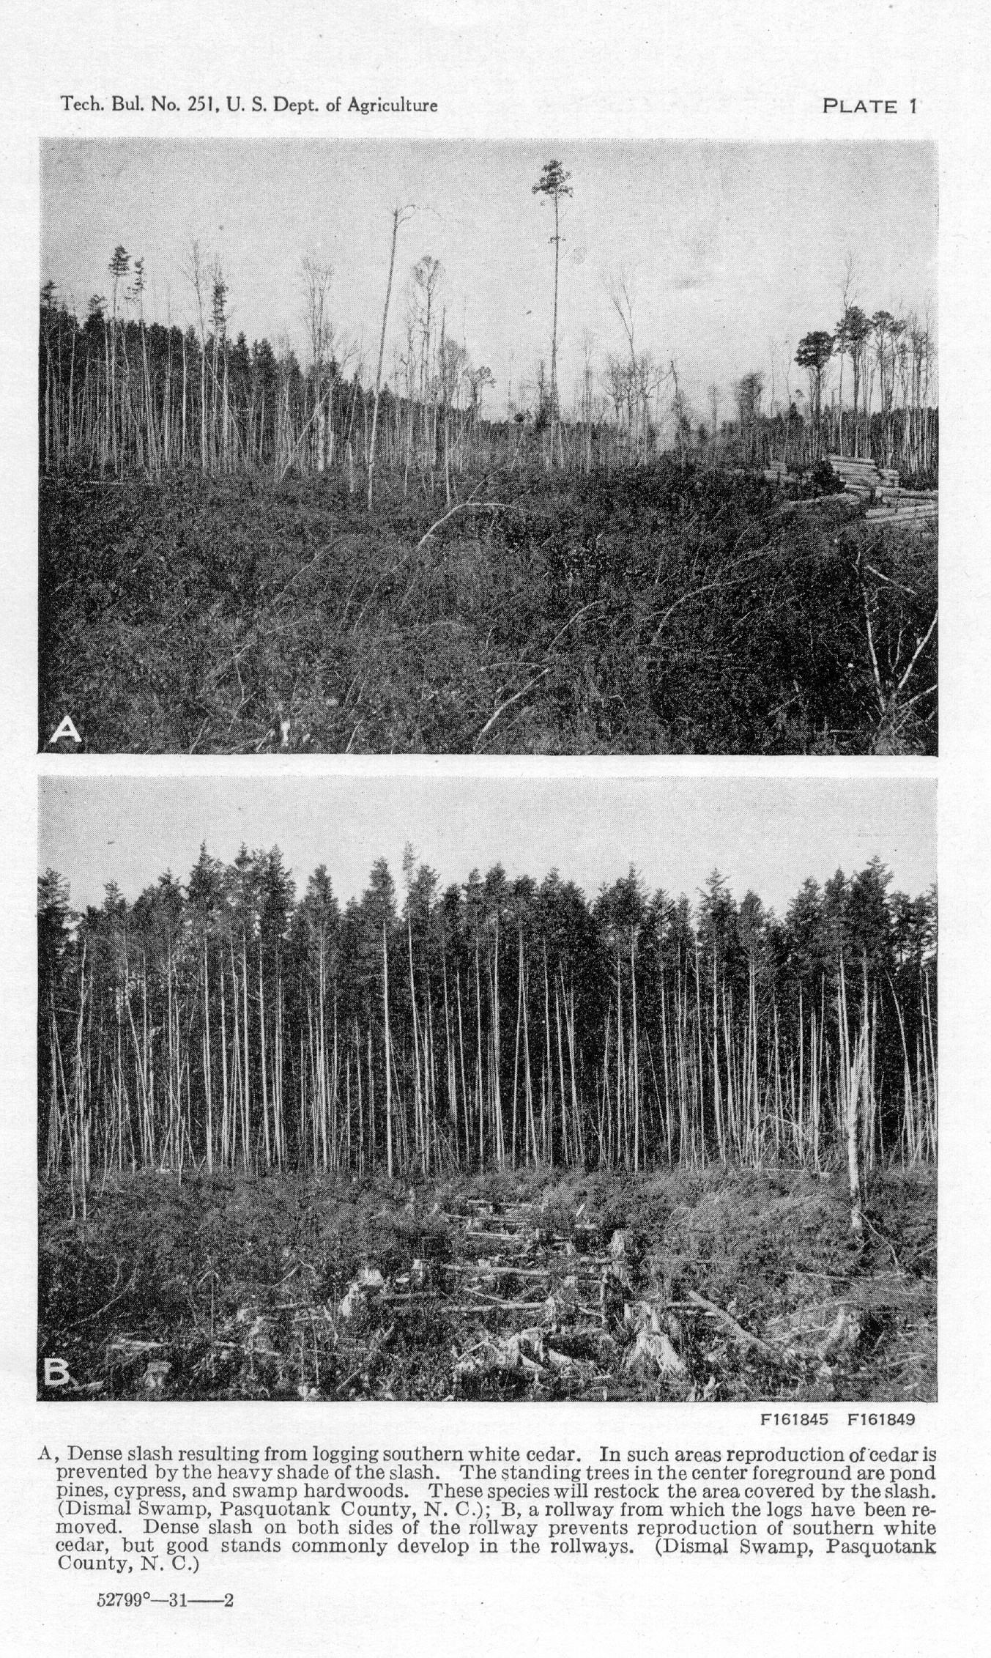
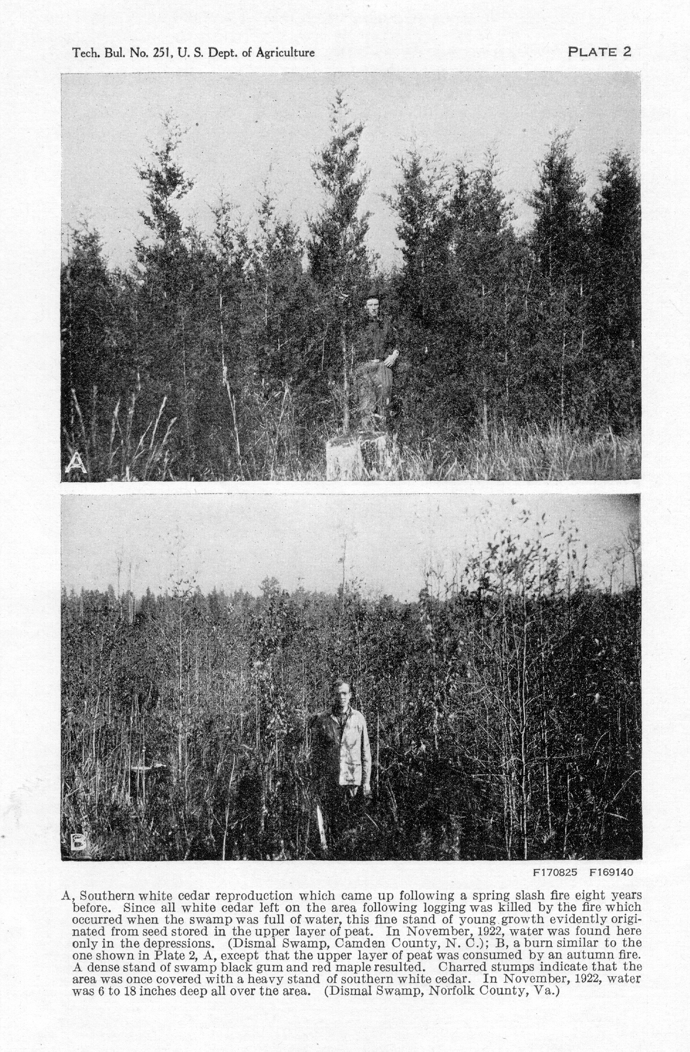
SOUTHERN WHITE CEDAR 17

upper layers may fluctuate to such an extent as to become a controlling factor. When the water table is low, as during the summer and early autumn, many seedlings that started in the moss on stumps and logs and on hummocks die from lack of moisture. When the water table is high, as in the winter and spring, many seedlings which germinate in the depressions or on areas subject to prolonged flooding are drowned. At such times the cedar seedlings that survive are those on the small hummocks of peat around stumps, on moss-covered logs and stumps, and in rotten wood above the general water level. The warm, open situations, such as recent burns in water-filled swamps, recently cutover lands, and clearings, offer the best conditions or the establishment of young cedar stands.

INFLUENCE OF COMPETING VEGETATION

Although white cedar seedlings frequently start under a cover of swamp shrubs, the shade is generally so dense as to hinder or prevent seedling establishment. The swamp shrubs, because of their extreme tolerance of shade, are abundant even under dense stands. When the overstory is cut, the undergrowth of shrubs, vines, and cane, under the influence of increased light, may develop into a dense, almost impenetrable jungle, in which the white cedar seedlings become established with great difficulty. The swamp hardwood trees further increase the density of this tangle of vegetation. Where the underbrush and hardwoods are cut or broken down, as in the rollways and tramways, the cedar reproduction develops with little competition; but between the rollways and tramways the seedlings are often hindered by the competing vegetation.

INFLUENCE OF LOGGING SLASH

The dense slash 2 to 4 feet deep left after logging heavy stands in southeastern Virginia and eastern North Carolina is another hindrance to the establishment of reproduction.⁸ (PI. 1, A.) Measurements show that in logging operations about three-fifths of the cut-over area is covered with slash and underbrush after logging and that the remaining two-fifths is left clear. (PI. 1, B.) The white cedar seedlings come up in dense stands in the cleared areas between the masses of slash. Old rollways and tramways are often marked by the dense reproduction that comes up in them. Actual counts on small areas have shown from 100,000 to over 2,000,000 cedar seedlings per acre, I to 3 years old, on recent cuttings and over 30,000 to the acre in the same situations on 8-yearold cuttings. The cedar reproduction is usually so dense in the rollways and tramways that the sprout growth of swamp hardwoods and shrubs is forced to a subordinate position in the stand.
On the other hand, few seeds germinate, and a still smaller number of seedlings survive in the cool dark situations under the dense slash between the rollways and tramways. (Table 2.) The hardwood sprouts come up through the dense slash, and by the time the slash has decayed sufficiently to form suitable seed-bed conditions for
⁸ In New Jersey the usual clear-cutting results in practically all slash being concentrated on narrow corduroy roads, called “crossways” or “causeways,” built for hauling out the products; thus most of the area is left in good condition for reproduction.

TECHNICAL BULLETIN 251, U. S. DEPT. OF AGRICULTURE 18

cedar-in 5 to 10 years-the hardwoods have become so tall that they form the body of the stand to the exclusion of the cedar. Areas of dense slash interspersed with the cleared areas therefore tend to result in mixed stands of white cedar and swamp hardwoods on unburned cutting areas.

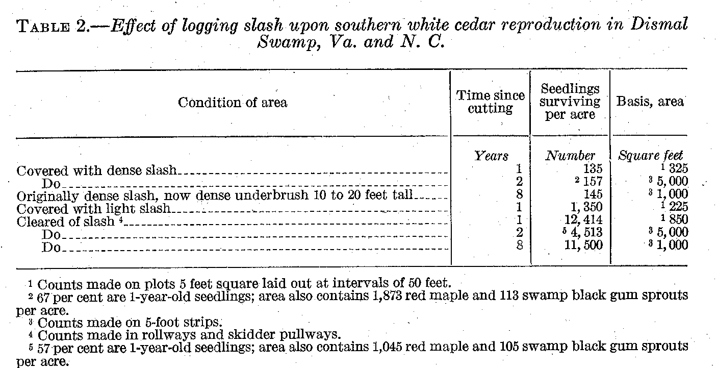

INFLUENCE OF SLASH FIRES

The slash left after logging is very inflammable and the slash fires, which are very common, customarily burn down to the water level. The living underbrush also burns and increases the destructiveness of the fire. When the water table is lowered during dry seasons, the drying out of the litter, moss, and peat adds to the fire hazard and greatly increases the seriousness of the fire. With the destruction of the upper layer of peat, the accumulated seed, which would otherwise give rise to new stands of cedar, is destroyed.
In the numerous instances in which dense stands of white cedar reproduction have sprung up on clear-cut areas following single slash fires, the fires occurred when the swamp was filled with water and before the seed dormant in the peat had germinated. (PI. 2.) All these areas have escaped disastrous fires during the dry seasons following logging. An instance of a severe slash fire which did not destroy the seed because the swamp was flooded at the time is the Dismal Swamp fire of Easter Sunday, 1913. This fire covered several thousand acres of recently cut slash. All of this area not burned over a second time restocked promptly with cedar. In general, cutover cedar areas burned the spring after cutting, when the swamp was filled with water, were found to have restocked within six years after the fire, with an average of 3,000 to 3,500 white cedar seedlings per acre.
However, the disastrous effects of a single fire during a dry season or of a second burn at any time cannot be overemphasized. Such burns generally result in a more or less complete change in the composition of the succeeding forest (4). When the original stand of southern white cedar is destroyed, together with the seed in the upper layer of peat; the new stand is likely to be dominated by thicker-barked Pines in the original stand which can resist any ordinary fire and reseed the area , In Virginia, North Carolina, and South

SOUTHERN WHITE CEDAR 19

Carolina this will be pond pine (fig. 9) and in the Gulf States slash pine. A severe dry-season fire which destroys most of the pines, together with the white cedar, or one which consumes a large amount of peat, results in a stand in which swamp hardwoods are predominant. (PI. 2, B.) These hardwoods will sprout and come up through a foot or more of water.

GROWTH AND DEVELOPMENT OF THE STAND

The growth of southern white cedar is moderately rapid, its rate depending chiefly upon the quality of the site. Growth is also influenced by density of stocking and condition of the stand.
Throughout the life of the stand the trees compete with each other for light and growing space above ground and for water and growing space below ground. For the first few years the seedlings are seldom numerous enough to utilize all the growing space available, and competition is not intense except in small, dense patches. The seedlings

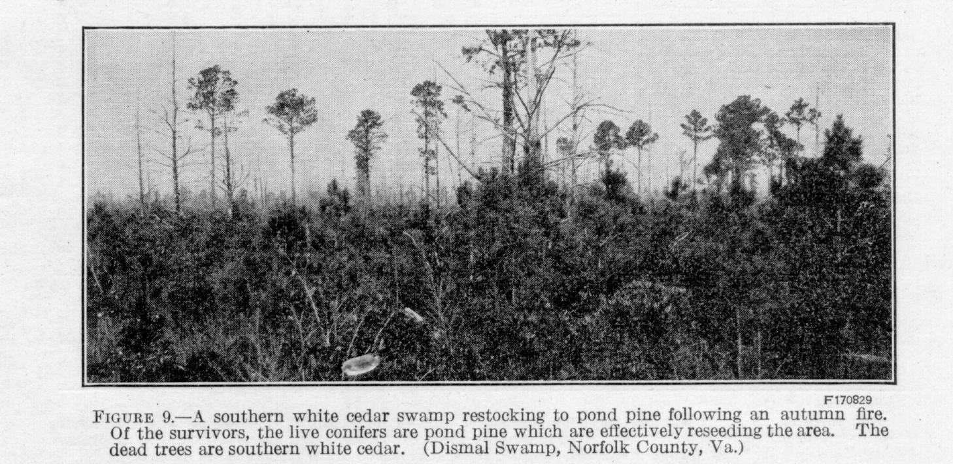

grow rapidly in height and soon become tall and slender. After a few years the increase in height, crown width, and spread of roots is sufficient to cause crowding in reproduction of average density. The trees that are largest because of more rapid growth the first few years are better fitted to continue growth at an average rate, as shown in Table 3. The shorter trees with small crowns grow more and more slowly until they literally die of starvation. In 10 or 15 year old stands the crowns have usually closed together, and a difference in size of the trees becomes noticeable. At this stage of development the surviving frees can conveniently be grouped into crown classes, based on the relative intensities of light received.
During this period, on the better sites, any southern cypress growing with the white cedar will be exceeded in height by the cedar, as shown in Table 4. , When it is thus overtopped, the cypress may remain some time before being shaded out but seldom endures until the maturity of the stand. Table 4 also shows that where pond pine occurs its height growth is more rapid than that of the cedar, a tendency that may be attributed to pond pine's intolerance of shade, which compels it to attain dominance in the cedar, stands or be

TECHNICAL BULLETIN 251, U. S. DEPT. OF AGRICULTURE 20

shaded out. Although this dominant position is successfully held by those trees that attain it, the proportion of pond pine in the stand is generally very small.

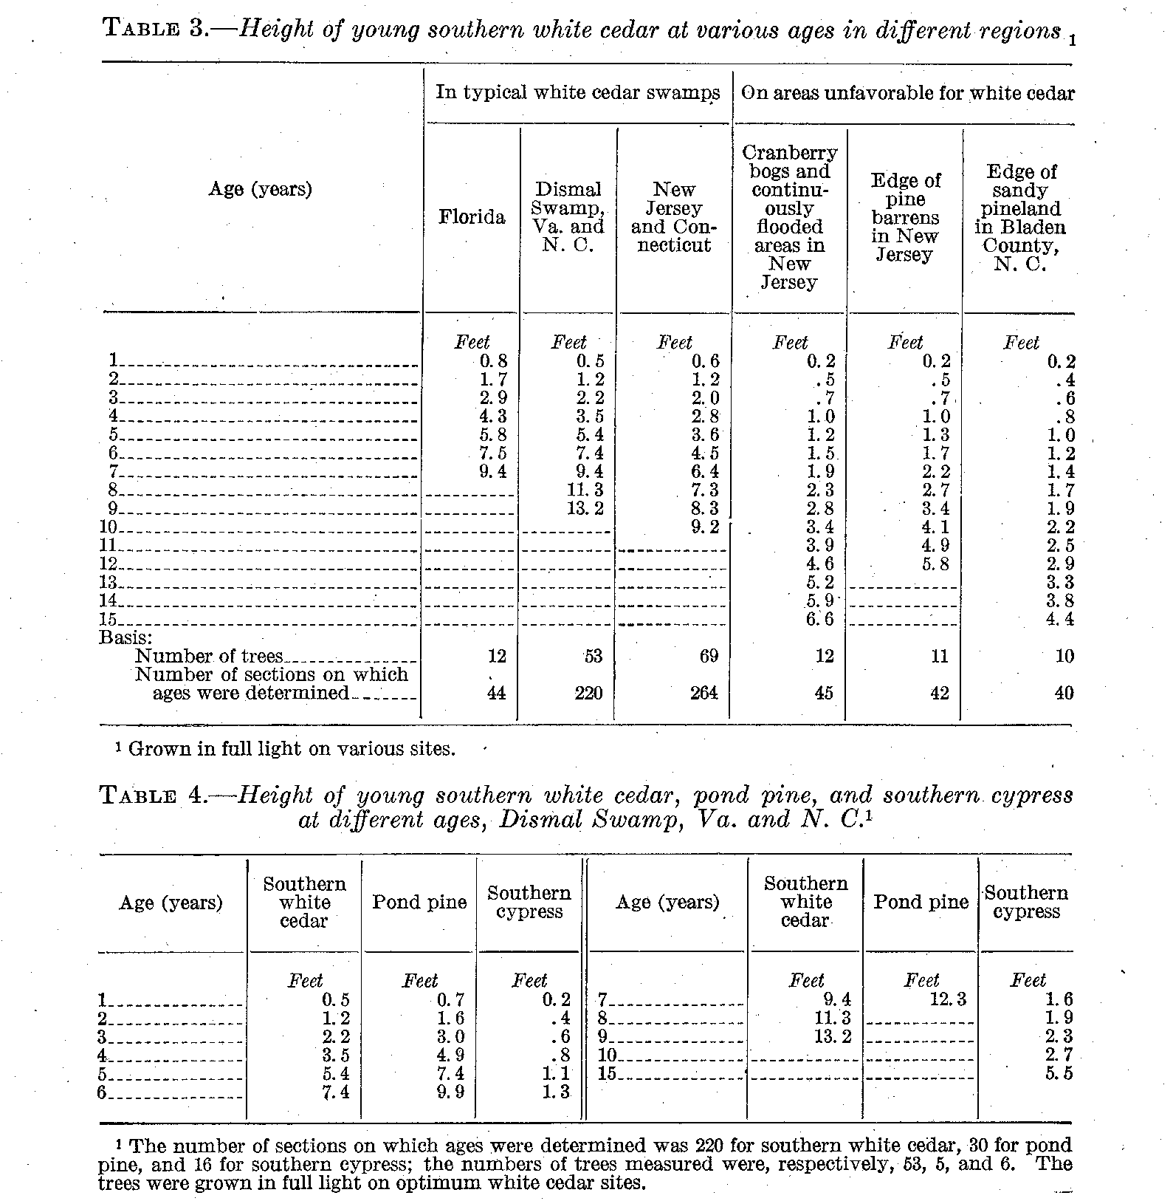

Not all young white cedar stands behave in the manner just described. Many even-aged stands are so dense from the start that they begin to stagnate after the first few years, especially on the poorer sites. Stagnation, or the mutual suppression of the growth of all trees, is due to intense competition and resultant reduction of foliage. The lower branches are killed by shade, making the crowns so short that growth is greatly retarded. The differentiation into crown classes is correspondingly slow. When released from this intense competition and given the opportunity to develop larger crowns capable of sustaining increased growth, the trees that are not too old or have not been suppressed too long will grow again at the usual rate.

SOUTHERN WHITE CEDAR 21

From the time the crowns begin to touch and crowd each other the differentiation in height, diameter, and form becomes rapid. On the better sites an annual increase of 1 to 1 1/2 feet in height and 0.1 to 0.15 inch d. b. h. is maintained by these trees until they reach an age of 40 to 50 years. After this age the height growth gradually decreases, practically ceasing at an age of about 100 years. Diameter growth, although reaching its maximum rate at about 50 years, continues at a rate of 0.1 to 0.15 inch a year for the next 50 years.
trees growing in open stands have a more rapid rate of diameter growth (Table 5), but the height growth is about the same.
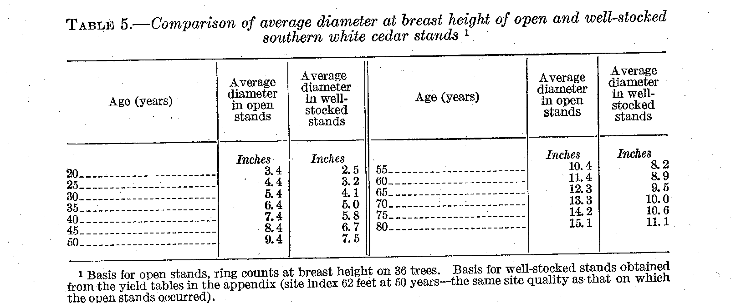

The conifers associating with southern white cedar in swamps which are not too deeply or continuously flooded commonly take the lead in rate of diameter growth. Table 6 gives a comparison of diameter growth of southern white cedar, hemlock, and white pine on a moderately poor cedar site in Connecticut. Other comparisons of average breast-high diameters reached at an age of 50 years are as follows: On the better cedar sites in the Dismal Swamp in Virginia, pond pine 10.1 inches and white cedar 8.2 inches; in a river-edge swamp in Escambia County, Ala., spruce pine 11.8 inches and white cedar 7. 8 inches; in a cedar swamp near Poplarville, Miss., slash pine 9 inches and white cedar 7.4 inches. The figure for slash pine agrees with that given by Mattoon (5) for the poorer slash pine lands. In Calhoun County, Fla., slash pine in association with white cedar is growing at a rate somewhat above that given by Mattoon for the better slash pine lands. Many similar cases of greater growth of the associated species have been observed but not recorded.

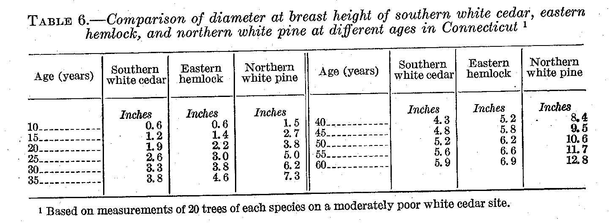

TECHNICAL BULLETIN 251, U. S. DEPT. OF AGRICULTURE 22

In any stand the stems of the tall, full-crowned trees have more rapid taper than those of the smaller trees with shorter crowns. (Table 7.) Trees grown in dense stands have shorter crowns, less taper, and greater volume than those of the same height and diameter in open-grown stands, although their growth rate is less. The growth Possibilities of a tree are reliably indicated by crown development and vigor. Vigorous trees have dense, deep green, full, pointed crowns. Southern white cedar trees with long, narrow crowns generally grow more rapidly than those with short and wide crowns. In raising timber, it is desirable that the volume growth be made by rapid-growing trees that are as free of branches and have as little taper as possible. When both form and rate of growth are considered, 40 to 50 per cent of the total height is probably the most desirable proportion of crown for southern white cedar. Trees with longer crowns are too limby, and those with shorter crowns normally too slow growing.

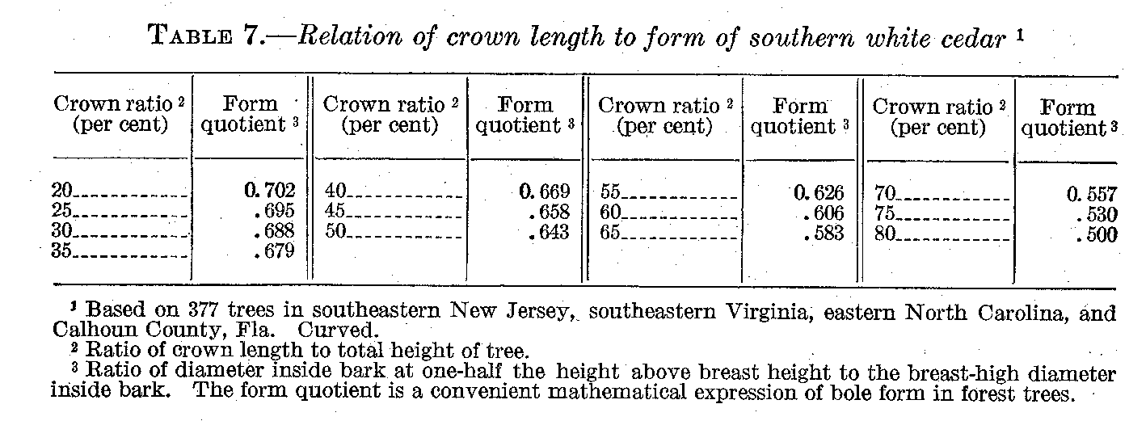

The range in diameters in even-aged stands varies with the density of stocking; in dense stands the range is small and in open stands large. In any stand trees of the smallest and largest diameters are relatively infrequent, and the number of trees in any size class increases as the diameter approaches the mean or average of the stand. The same is true of the heights, although the distribution is not quite the same as with diameters and the influence of variation in density is very much less.
The relation between diameter at breast height and height varies with the age of the stand and its density. The height-diameter curve for young, nonstagnant cedar stands (diameters under 4 to 5 inches) is usually a straight line, as A in Figure 10, but in stands of larger and older trees it becomes a curve of the general type shown by B, Figure 10.
ln southern white cedar stands the weakest, overtopped trees die rapidly. Mortality is naturally greater in dense than in open stands, because of the more intense competition. The number of trees killed by competition is large in young stands but gradually decreases as the stand becomes older. The loss of the wood contained in these smaller, overtopped trees is more than offset by the growth of the larger trees remaining, so that the volume of the stand increases fairly rapidly.
Both value and volume of wood increase with age until the stand is mature. The increase in volume is then offset more and more by

SOUTHERN WHITE CEDAR 23

increased mortality. The increase in diameter becomes very small, and height growth practically ceases. After a time the losses exceed the growth, and the stand becomes decadent.

YIELDS

Because of the great variations between different sites it is desirable to have some measure of their productivity. Volume would be the

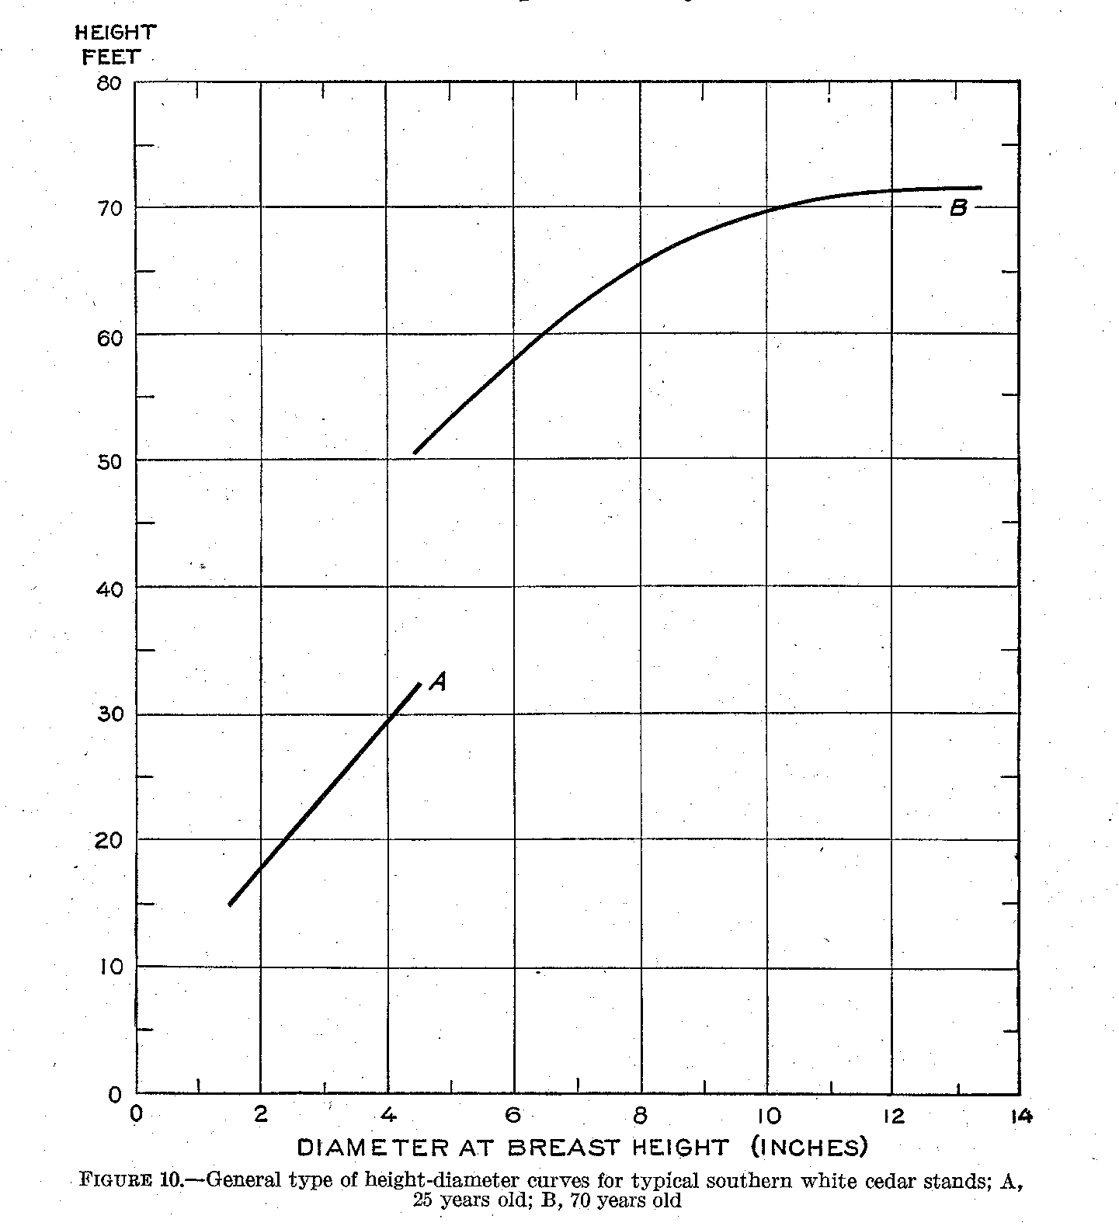

most desirable measure if it were not greatly affected by density of stocking. Diameter growth also is influenced by density. The only characteristic which is affected only slightly, if at all, is the height that free-growing or dominant trees attain at given ages. As already shown, height varies only slightly among the trees of larger diameter in a stand, and the height of the average dominant can safely be used as an index of the productivity or quality of a site. Since

TECHNICAL BULLETIN 251, U. S. DEPT. OF AGRICULTURE 24

height varies with age it is necessary when comparing two or more stands to compare their heights at the same age. An age of 50 years is commonly used as the basis of site classification. This standard age was used in the prep-aration of yield tables for southern white cedar.
The yield of a stand-that is, the amount of wood produced per acre-depends on the number and volume of the individual trees composing the stand. In well-stocked, even-aged stands the number of trees per acre and the rate of growth depend largely on age and site quality. These factors, therefore, determine the rate at which the number of living trees decreases through competition as the stand develops. The decrease in the number of trees, however, makes more growing space available for the remaining trees and is more than offset by the large size of the survivors. Even when the decrease in number of trees is most rapid, the total basal area⁹ and the volume per acre continue to increase, rapidly on the better sites and slowly on the poorer ones.
Detailed tables giving yields at various ages for well-stocked, even-aged stands of white cedar on six different qualities of site are given in the appendix. (Tables 20 to 39.) These tables show that 50-year-old stands in which the dominant trees attain a height of 60 feet contain an average of 65 cords to the acre, whereas on poor sites that are capable of producing dominant trees only 30 feet tall the yield at the same age is only 10 cords. The yield of stands 100 years old may be as much as 54,200 board feet per acre (based on the international log rule, 1/8-inch saw kerf) on good sites producing 60-foot trees in 50 years, or as low as 6,550 board feet on poor sites.
These few examples clearly show that the yield of southern white cedar in even-aged stands, fully stocked as to volume, varies greatly with age and site quality. The size of the trees and the number per acre at a given age vary widely on different sites. Great variations are also evident between the number of trees to the acre in different stands on the same site. These variation, are due occasionally to slight differences in stocking and crown closure but usually to the death of trees in the understory. The understories of some stands have a large number of small living trees containing a small volume; others have many dead trees, recently killed by suppression, and but few live trees. Such differences in the subordinate stand, although they change the volume only slightly, cause pronounced variations in the total number of trees to the acre.
The Yields given in the appendix are for well-stocked stands which have developed naturally. A mature, well-stocked stand of white cedar forms a dense, unbroken crown cover. The narrow crown, suggestive of many trees to the acre, and the long clear stem are indicative of heavy yields. Where proper methods of forest management are employed and the stands are kept vigorous by thinnings at regular intervals, the total yields are materially increased. Not only are higher yields obtained, but the volume is contained in fewer trees of larger size than in unthinned stands. Timber of higher quality and suitable for a greater variety of uses is thus obtained.
——————————————————————————————————————————————
⁹ Basal area is the cross-sectional area of a tree expressed in square feet and usually refers to the section at breast height. The sum of the basal areas of the trees in a stand is the basal area of the stand and is usually expressed in square feet per acre.

SOUTHERN WHITE CEDAR 25

The yield tables are useful not only as guides to the present approximate yields of existing well-stocked, even-aged stands but also as a means for predicting the future yields of such stands. They should by no means, however, be used as a substitute for a timber survey when an accurate inventory of growing stock is wanted. Precise future yields cannot be predicted, but with the aid of the tables reasonably reliable forecasts of the yields of young second growth stands can be made. These tables were prepared from measurements of typical, even-aged stands covering a wide range of ages and qualities of site. They are based on, and therefore applicable to, well-stocked stands-that is those which contain enough trees to utilize all the growing space and produce the maximum volume of wood. Maximum volume production can be attained with either a large number of small trees or a smaller number of large trees. Under the latter conditions maximum board-foot production may become coincident with maximum cubic-volume production. Since the yield tables are based on plots in which the number of trees varies widely, the board-foot yields given in Tables 35 and 39 are probably not the maximum obtainable, though the cubic foot and cord yields may be close to the maximum.
Since the yields given in the tables are for well-stocked stands grown under natural conditions without thinnings or other treatment, the approximate yields of other even-aged stands, of white cedar can be computed from these tables if the age, quality of site, and density of stocking are known.
Age is determined by counting the annual rings either on stumps of felled trees or, for standing trees, on cores removed by boring to the center of the bole at about stump height. When the age and height of the dominant trees of average basal area are known, the index of site quality, or site index, can be read from the height-age curves (fig. 17 in the appendix) used as the basis for site classification in the construction of the yield tables.
The total wood volume per acre produced by a stand within a given time is probably the best criterion of density of stocking, but its determination requires detailed measurements and difficult computations. The total basal area per acre is a more easily applied and yet reasonably accurate criterion of the density of stocking. The basal area of the stand, as computed from the diameter at breast height of all trees composing the stand, divided by the basal area given in the yield tables, for the same age and site index, gives the percentage of stocking. Similarly, the yields of overstocked stands may be considered as proportional to the percentage deviation of their total basal areas from those given in the yield tables for wellstocked stands of the same age.
Yield tables for well-stocked stands are less applicable to long-time forecasts of yields from greatly understocked stands because, as previously shown, diameter growth of understocked stands, before crown closure occurs, exceeds that indicated by the yield tables. If used, however, the predictions will probably be conservative. Until the rate of stand closure is determined, by periodic remeasurements of stands of different densities, satisfactory yield predictions can not be made for such stands. Fortunately, however, understocked stands of southern white cedar are much less common than well-stocked or overstocked stands.

BULLETIN 251, U. S. DEPT. OF AGRICULTURE 26

MANAGEMENT OF SOUTHERN WHITE CEDAR

The great variety of commercially valuable products derived from southern white cedar makes it a desirable species to grow, and its rapid growth, heavy yields, and ease of reproduction make it peculiarly adapted to forest management. This species, if grown on potential cedar-swamp lands under proper management, will probably produce greater revenues than could be obtained from any other use of such lands.

LAND UTILIZATION

The belief that white cedar swamp lands can be profitably cleared and drained for growing field and truck crops is prevalent in some localities. The peat on these lands, consisting of a reddish-brown stringy mass of cedar leaves, bark, wood, and other vegetable matter, is, however, very poorly decomposed. It contains only a trace of soil, although it is underlain by sand at depths of 2 to 10 or more feet. A sample of peat from Hyde, County, N.C., was analyzed by the Bureau of Chemistry and Soils, United States Department of Agriculture, and found to contain 88.8 per cent organic matter (loss on ignition), 0.33 per cent lime, 0.1 per cent potash, and 0.02 per cent phosphoric acid. Only a very small proportion of the nitrogen contained in the peat is available as plant food. The correction of the acidity would require lime at the estimated rate of 13,200 pounds an acre, too much for profitable production of field or truck crops.
It is not surprising that a number of attempts to clear, drain, and farm southern white cedar swamps have been decidedly unsuccessful. When the swamps are cleared and drained the surface peat has a strong tendency to cake and harden beneath the sun's rays, until it resembles charred wood. White cedar land has proved itself practically worthless for the production of crops, save at a heavy financial outlay.
Although a number of cedar swamps in New Jersey and Massachusetts have been converted into cranberry bogs, and cranberry growing usually brings higher net returns from the land than the production of white cedar timber, little increase in the acreage of the crop is to be expected in the near future. The entire area of potential southern white cedar land now in cranberry bogs is estimated at between 15,000 and 20,000 acres, and the cranberry industry is conducted on such an intensive scale that a relatively small acreage is sufficient to meet the demand. According to all available information it is evident that by far the greater part of the potential cedar swamp lands, especially those underlain by sand, can best be used for the continuous production of southern white cedar.

TREATMENT OF STANDS

The main object in managing forest lands is to obtain, in the shortest possible time, a maximum sustained yield of merchantable timber of the sizes most desired. A method of cutting designed to obtain complete natural reproduction is required, together with protection of the stand from fire and other injurious agents.
The age at which the stand should be cut will be determined by the size and kind of material desired and by the financial returns accruing from rotations of different lengths. When the timber has reached a size most suited for utilization it is best to market it and start a new fast-growing timber crop.

SOUTHERN WHITE CEDAR 27

METHOD OF CUTTING

Cutting, in forest management, is an intermediate step in the continuous process of timber production. It must be so conducted as to result in ample reproduction. The reproductive characteristics and requirements of a species play a very important part in determining the method of cutting. The essential requirements for the formation of fully stocked stands of southern white cedar are as follows: (1) A sufficient seed supply; (2) an abundance of light; and (3) little competition from other trees or shrubs. These requisites are easily provided. The close utilization practiced allows very clean cuttings, admitting the abundant light needed for reproduction. A large amount of seed is usually available, ready to germinate and establish a seedling stand. Competition of other trees and shrubs is not to be feared if as will be shown later, fires at the wrong time can be avoided.
Since southern white cedar is very susceptible to wind throw and fire, seed trees, are of little value. The few trees that may be left

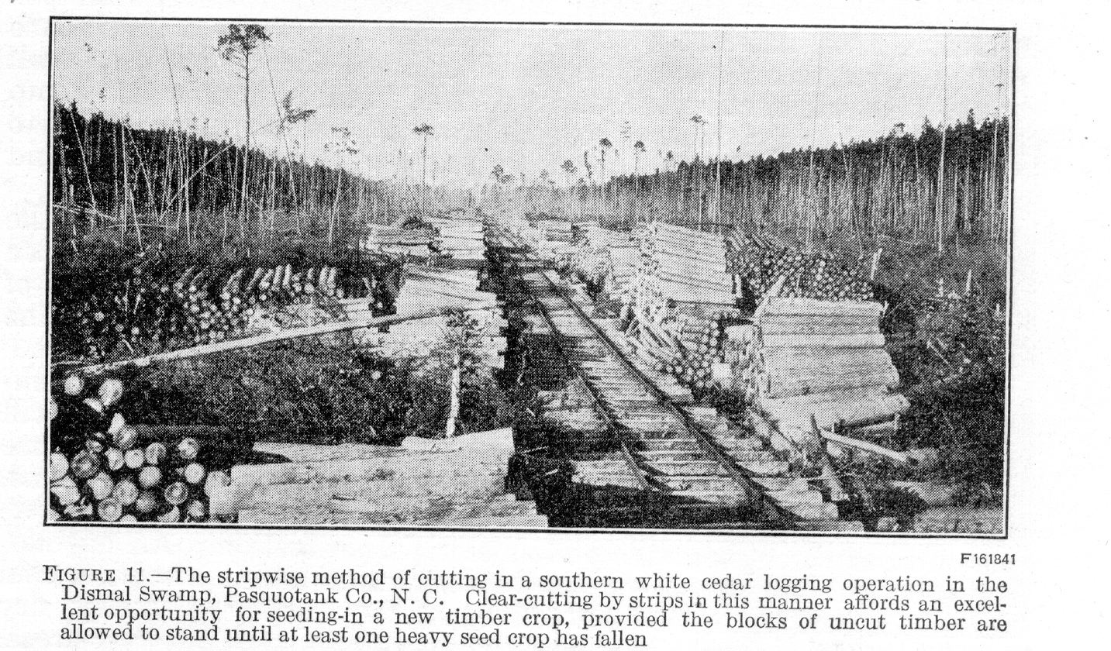

standing on the heavily cut areas, and which might serve as seed trees, are generally blown down soon after cutting.
A very desirable method is to cut the forest clear in strips not more than 1,000 feet wide, leaving uncut strips of green timber between the cuttings. If the strips are located approximately at right angles to the direction of the storm winds, seed from the intervening uncut strips will be effectively distributed over the clear-cut strips. The strips of uncut timber should generally be left intact. This method has the advantage of insuring ample reproduction should the seed present be destroyed or should there be any doubt as to its adequacy.
Although strip cutting is not generally practiced, stands of southern white cedar have occasionally been cut by this method. In New Jersey one owner has cut a strip each year, gradually working over the entire swamp. This not only proved a convenient way to operate but also resulted in well-stocked stands of reproduction on the areas cut. In the Dismal Swamp several operators, who have combined hand logging with railroad transportation, have followed a stripwise

TECHNICAL BULLETIN 251, U. S. DEPT. OF AGRICULTURE 28

method of cutting, although sufficient time to insure reproduction has not always elapsed between the cutting of adjacent strips. (Fig. 11.) This method of logging involves the location of railroad spurs so that the rollways extend out on both sides of the spur for a distance of 100 to 150 yards. The distance between blocks of uncut timber is 200 to 300 yards, but no part of the cut-over area lies beyond the seeding distance of southern white cedar. By judiciously planning the logging operation it should be possible, without requiring a prohibitive amount of railroad steel, to allow the blocks of uncut timber to the windward side of the cut-over areas to stand until at least one heavy seed crop has been disseminated.

SLASH DISPOSAL AND FIRE PROTECTION

It has already been shown that few cedar seedlings can make their way through slash. Slash burning, therefore, may in many instances be necessary to insure well-stocked stands of reproduction. Burning should be done the first winter following logging, when the swamp is full of water or sufficiently wet to prevent the destruction of surface peat that commonly contains considerable white cedar seed. Such controlled slash burning will destroy the rank sprout growth of swamp hardwoods, shrubs, and vines which are so distinct a hindrance to cedar reproduction; when they sprout again the cedar by its rapid height growth will overtop them.
If it is impossible to burn the slash under favorable conditions the first winter following logging, areas of slash should be rigidly protected from fire for 5 to 10 years following logging. The shorter period of intensive protection will be required in the south because of the more rapid decay of the slash there than in the north.
Such rigid protection should consist of maintaining on slash covered areas a protective force sufficient to insure that any fire will ordinarily be discovered and reached within one hour of its occurrence by a crew of men adequate to control it. If logging is in progress the entire crew should be subject to call to fight fire during all dangerous seasons throughout the period of rigid protection. All engines, skidders, loaders, and other logging equipment burning wood or coal should be equipped with effective spark arresters. During dry periods smoking should be prohibited on all unburned cut-over areas.

CLEANINGS AND THINNINGS

To produce the heaviest yields and best quality of southern white cedar timber in the shortest time, thinnings are necessary. The purpose of thinnings, in addition to some salvage of the many small trees that would otherwise die and rot, is to maintain the stands at the density most favorable for growth of the better trees. The trees remaining after thinning should be close enough together to utilize all the growing space and produce well-formed holes, but not so close as to slow down the growth materially.
Where more than a single thinning is practical the interval can be judged by the rate at which the crowns extend laterally, which varies with the rate of growth of the trees and therefore with site quality and age. Thinnings should leave the stand uniformly opened to an extent which insures that the crowns will not close together to form a continuous crown canopy in less than 8 to 10 years, or the period it would probably take the crowns of dominant trees to close a space of

SOUTHERN WHITE CEDAR 29

5 or 6 feet under average conditions. Young, dense, rapid-growing stands on the best sites may need thinning after an interval of 10 years, while older, slow-growing stands on relatively poor sites would not need to be thinned a second time in less than 20 years,
The natural growth of southern white cedar stands is attended by a heavy death rate, caused by intense competition. (Fig. 12.) A well-executed program of thinning, will not only prevent loss and stagnation in the stand, but will also promote rapid growth in just enough of the trees to occupy finally the full crown area. Thus a crowded stand containing originally several thousand seedlings to

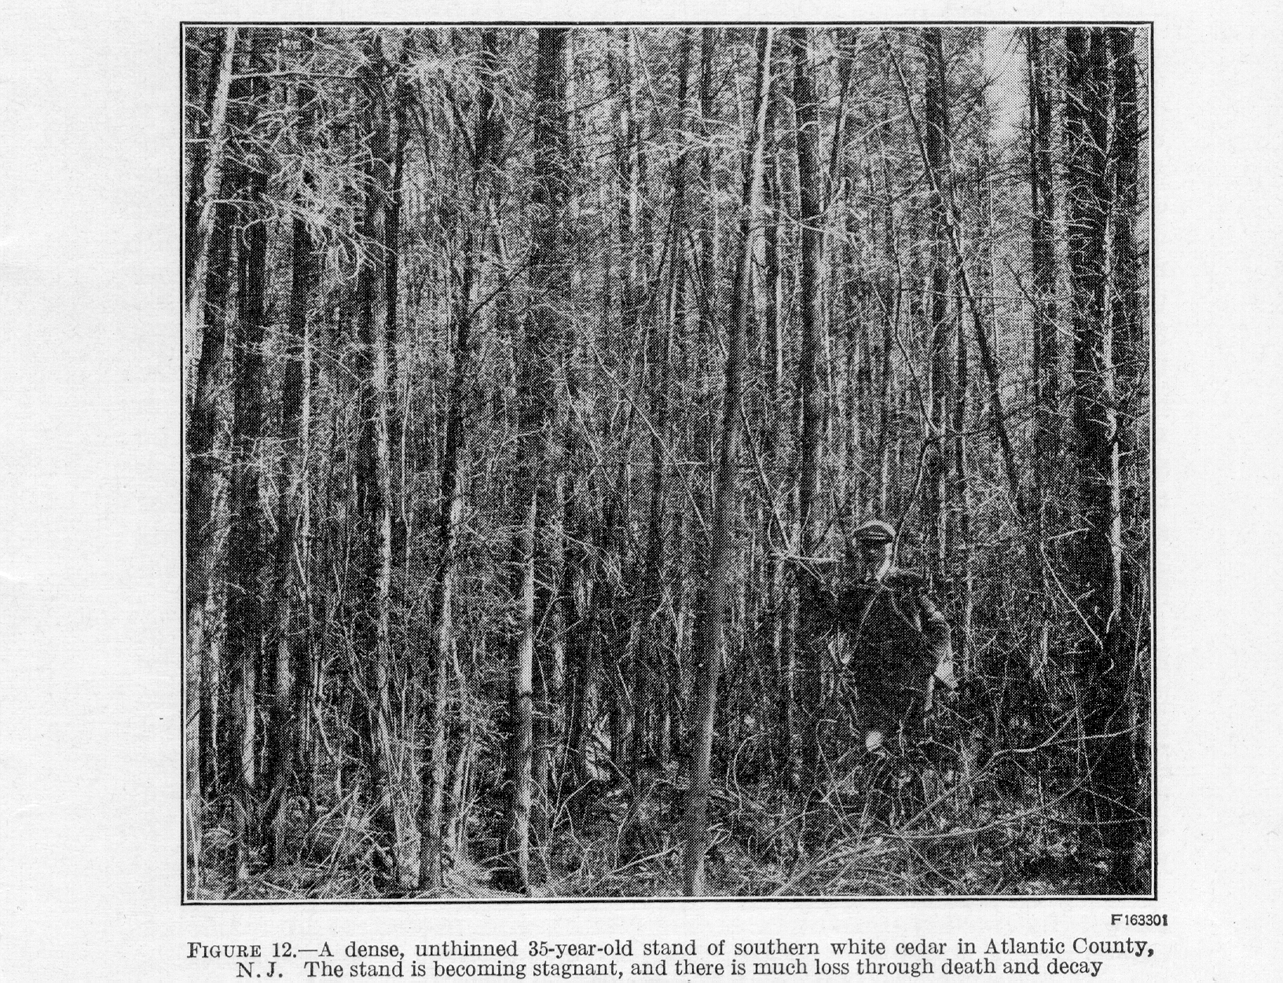

the acre may be reduced to a few hundred trees at maturity, carefully selected, and of high quality. (Fig. 13.) In this way the volume growth of the entire stand is concentrated and improved in quality. The trees reserved for the final cut will be larger and better formed than those in unthinned stands, and the yield will be considerably increased by the material salvaged in the thinning. Also the rotation, or length of time between successive crops of mature timber may be shortened.
In addition to thinning, it may sometimes be necessary to rid the stand of undesirable trees, whether of cedar or other species. So far as practicable, young stands should be cleaned or weeded of poorly formed and diseased trees and of trees of less valuable species which might otherwise usurp the growing space and cause the death of

TECHNICAL BULLETIN 251,U.S.DEPT. OF AGRICULTURE 30

better trees. When the trees removed possess sprouting ability, as the swamp hardwoods, it may be desirable to resort to one or two additional cleanings, made at intervals of about five years. On cutover areas where the slash is not burned, cleanings will doubtless be very desirable to free the cedar from the competition of the swamp hardwoods. Girdling and poisoning with sodium arsenite are probably the best means of eliminating the larger swamp hardwoods. In poisoning, cuts should be made through the live inner bark to facilitate more uniform distribution of the poison. In girdling, it will be necessary to cut somewhat deeper into the sapwood in order to kill the trees.
In New Jersey, where stands have ordinarily been handled on a 70 to 80 year rotation, the experience of the State forest service has demonstrated the economic advantages of only one moderately heavy thinning during the life of a stand.¹⁰ This thinning, made preferably at the age of 35 to 45 years, removes, the overtopped, intermediate, and some of the co-dominant trees and leaves from 700 to 1,000 trees per acre. It was earlier believed that such a thinning would result in serious damage by wind throw, snow, or ice; but it was found that if the swamps were protected on the windward side, such damage was confined mainly to small trees, which probably should have been removed in the thinning. More than a single thinning is hardly justified here, because of the heavy cost of cutting the underbrush and removing the material cut. This cost must be met from the sale of the trees removed before a profit is realized; thus products must have a high unit price and be available in large numbers per acre. Present results in New Jersey indicate that thinnings in stands 20 to 25 years old are of doubtful value, both financially and in actual benefit to the remaining stand on such sites.
Shade-tree stakes and the other small-sized products available in large numbers per acre and at a high unit price can obviously be removed but once during the rotation. If a later thinning were made, larger-sized material would necessarily have to be cut, and in order to make the thinning profitable, so much growing stock would probably have to be removed as to reduce materially the value of the mature stand. Hence, in a stand managed under a 70 to 80 year rotation, a second thinning has not appeared practical.
The cedar thinnings made from 1921 to 1928 by the New Jersey Forest Service are indicative of the results and profits to be expected where a good market exists for small-sized products. Here profitable thinnings may be made in relatively young stands when the products of thinning are first marketable (1). In 1921 a 35-year-old stand of white cedar, near Atsion N. J., containing 2,656 trees per acre, ranging from 1 to 8 inches in diameter, was thinned to 1,592 trees to the acre. From the trees removed in thinning, ranging from 1 to 5 inches in diameter, 1,240 bean and rustic poles were sold, at a net profit of about $35 per acre. Later observations indicate that this stand could have been thinned to about 800 trees per acre with out exposing it to loss by wind throw or snow and ice damage; in fact, it should have been thinned more heavily to get the best results of increased growth.
——————————————————————————————————————————————
¹⁰ The writer is indebted to former Associate State Forester W. M. Baker and Assistant Forester A. T.
Cottrell, of New Jersey, for the information on thinning southern white cedar in New Jersey.

SOUTHERN WHITE CEDAR 31

From 1926 to 1929 a total of 26 acres of southern white cedar was thinned on the Lebanon State Forest, in Burlington County, N. J. of the thinned area, 15 acres bore a relatively dense stand under 45 years of age and 11 acres supported a stand over 60 years old. The material taken out consisted of 40,000 shade-tree stakes, 42,000 bean and rustic poles, 4,500 arbor poles, 2,000 fence posts, and about 700 telephone poles and logs. These products were sold for $8,750. The products were removed from the swamp by means of a light push car operated by man power on a light steel track, consisting of 12 pound rails made up in 15-foot portable sections with metal ties. After deducting all costs of labor, tools, hauling 4 to 8 miles to the railroad, and depreciation on tramroad equipment, totaling $7,800, a net profit of $36.54 an acre remained. Owing to the relatively long

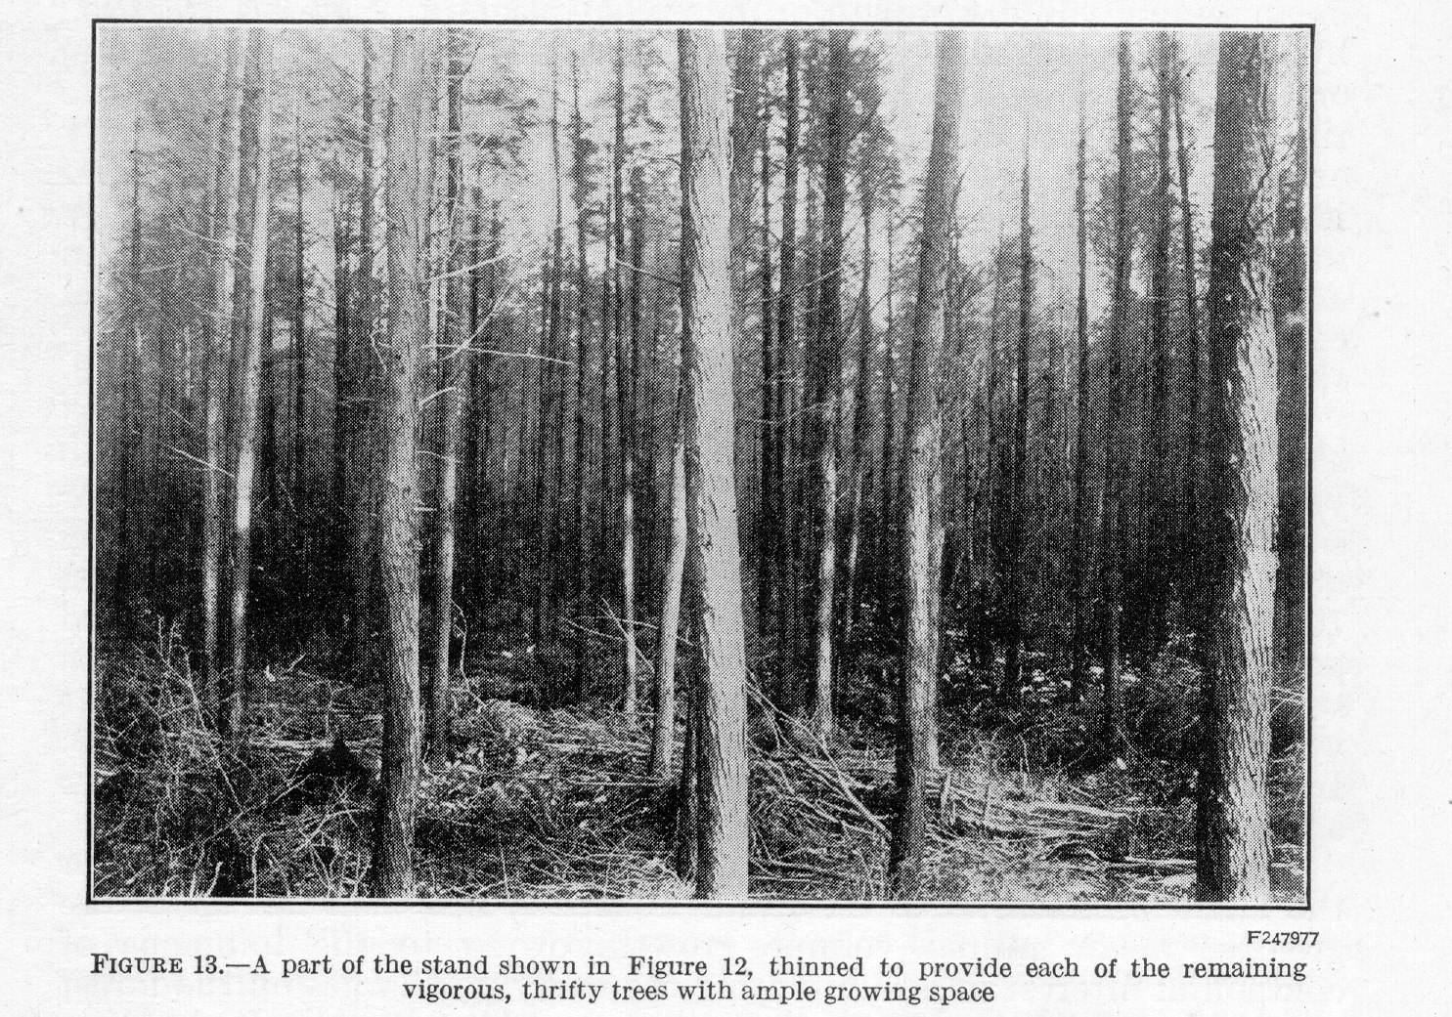

haul to the railroad and the fact that the swamp area thinned is surrounded by boggy approaches and extensive areas of deep sand, making hauling difficult, the New Jersey officials regard the cost of $300 an acre as approaching the maximum for cedar thinnings. They believe that under favorable logging conditions this figure can be reduced to $200 an acre and to about $250 for average New Jersey conditions on sites producing 40 to 50 foot white cedar in 50 years.
In, general, dense stands of southern white cedar should be thinned as early as the material removed can be marketed at a profit, or certainly before the stand has greatly stagnated. Profitable commercial thinnings will probably be restricted to dense, thrifty white cedar stands on sites capable of producing dominant trees 40 feet or more in height in 50 years. Where the stand can be thinned more than once, the best time for the first thinning is during the period of most rapid height growth, which occurs so early that enough Mer-
TECHNICAL BULLETIN 251, U. S. DEPT. OF AGRICULTURE 32

chantable material to pay the cost of the thinning cannot often be obtained. In the South, until small-sized material becomes merchantable, thinning can bring in a return only in stands containing larger-sized material. However, an early unremunerative thinning may sometimes be necessary to prevent stagnation and to bring about within the stand conditions favoring rapid growth. Such thinnings will probably pay in the end.

BEST TIME TO HARVEST THE TIMBER CROP

The length of rotation, or the number of years which elapses between the establishment of the forest and the time when it is finally cut, is an important consideration in the management of these cedar swamp lands. The rotation is determined by the age at which the mean annual volume growth or increment per unit of area is greatest; by the time required to grow the material desired, as cordwood, poles, or saw timber; by the highest net revenue to be obtained from the timber; or by the limitations of the species in reproductive capacity or resistance to decay. The time when the greatest mean annual increment occurs is probably the best basis for determining the age at which to cut the stand. The rotation can then be modified in accordance with the kind of material desired and with the financial considerations, such as taxes, cost of administration and protection, stumpage values, and market demands.
In terms of cordwood the greatest mean annual growth of unthinned southern white cedar stands occurs at 50 years on the best sites, at 70 years on average sites, and at 90 to 100 years or more on very poor sites. The greatest mean annual growth of unthinned stands in board feet of lumber takes place on good white cedar sites between 70 and 90 years of age and at well over 100 years on the average and poorer lands. The larger size of saw timber and the very dense stocking of the unthinned natural stands tend to increase the age at which the greatest mean annual volume growth of saw timber occurs. In thinned and well-managed stands this should occur at an earlier age.
The age at which the highest net money return will be obtained, or the financial maturity of the stand, is usually less than the age of the greatest mean annual volume growth, owing to the influence of compound interest in accumulating the carrying charges on the forest property decreasing net revenue. The important carrying charges include the interest on the initial investment in value of land and the annual expenditive for taxes, protection, and administration. With a stumpage price of $5 a cord, a charge of 10 cents an acre each year for administration and protection compounded annually at 4 per cent, and a yield or severance tax of 10 per cent on the gross yield at time of cutting, the highest soil rental is obtained at about 35 years for the best white cedar land, at 50 years for land of average quality, and at 60 years for poor land. With the same costs but with a stumpage price of $10 a thousand board feet, the greatest soil rental occurs at 50 years on the best sites, at 65 years on medium sites, and at 80 years on the poor sites.
The increase in stumpage price due to a rapid increase in quality of the larger-sized material that can be grown in carefully managed stands, together with the revenue obtained from thinnings, generally extends the financial rotation based on the greatest soil rent toward the period when the greatest mean annual board-foot increment
SOUTHERN WHITE CEDAR 33

occurs, on all except the poor sites. On good white cedar land the saw-timber rotation, as determined by financial considerations, may approximate that based on mean annual increment. When all the important factors are considered, a rotation of 40 to 50 years seems desirable for the production of cordwood and 60 to 80 years for saw timber in well-managed white cedar stands on all but the poorer lands.

FINANCIAL RETURNS
The profit or loss from investments in second-growth southern white cedar depends upon the commercial value of the stand and the total cost of producing the stand with interest compounded annually. The cost of production includes initial expenses and annual carrying charges. Interest on the initial land value is properly chargeable against the cost of timber growing. Since the land remains as an asset when the timber is cut, only the interest on the land value need be calculated as an actual enditure. The annual expense includes taxes on the land and annual costs of protection and administration, both chargeable as annuities at a specific rate of interest.
The determination of the relation of cost to financial returns is more complicated for timber crops than for other agricultural crops because long rotations involving compound interest must be considered, instead of simple interest for a single year. . The computation of financial returns from growing white cedar involves so many variable or speculative elements, such as lumber values, taxes, interest rate, and the influence of accessibility, that figures covering all the variable factors are rarely available. A few examples are given to illustrate the methods of determining financial returns and the extent to which they are influenced by such factors as quality of site, rotation, interest rate, and land value.
In these examples the cost of production, comprising interest on the value of the land and the annual expenses for taxes, administration and protection, is computed at 5 per cent interest to the end of the rotation. The annual expense for administration and protection is placed, at 10 cents an acre. An equitable form of taxation is assumed, consisting of a nominal land tax of 1 per cent of the full value of the bare land alone, payable annually, and a yield or severance tax of 10 per cent of the gross value of the timber when it is cut at the end of the rotation.
Cost of administration and taxes together at 25 cents an acre a year on $15 land at the end of 50 years amounts to $0.25 (1.05⁵⁰-1/1.05-1)=$52.34. The interest on the investment in $15 land for 50 years is $15 (1.05⁵⁰-1)= $157.01. The total cost of production therefore is $209.35. From Table 30 it is seen that the best white cedar land, which will which will produce 70-foot trees in 50 years, will yield 82.7 cords an acre at this age. With stumpage valued at $5 a cord the gross returns amount to $413.50, and after deducting a 10 per cent yield tax a net return of $372.15 remains. A net profit of $162.80 an acre is obtained after deducting the total cost of production. With the same cost of administration, taxes, interest rate, and gross returns, a land value of $10 an acre will increase the net profit to $267.48, while a land value of $30.55 an acre will eliminate the net profit. Also on cedar land of poor quality, capable of producing trees 30 feet or less in height
TECHNICAL BULLETIN 251, U. S. DEPT. OF AGRICULTURE 34

in 50 years, a land value of only $5 an acre will show no profit any rotation period.
An increase in the Stumpage price is reflected in higher net returns. With a stumpage price of $7.50 a cord and other expenses as in the foregoing example, the net returns at 50 years become $348.88 and $135.61, respectively, for land of good quality valued at $15 an acre and of medium productivity at $10 an acre. .
A low interest rate tends to increase the net profits from timber growing, and a sufficiently high interest rate will eliminate any profit which might otherwise accrue from the enterprise. With interest computed at 5 per cent compounded annually the profit to be expected in 50 years from white cedar lands of good quality has been shown to be $162.80. With an interest rate of 4 per cent the profit becomes $242.38, and with an interest rate of 6 per cent the profit is reduced to $38.27 on good land. On lands of medium and poor quality 6 per cent interest would result in losses.
Another method of determining financial returns from timber growing is that in which the entire returns are expressed as the actual rate of interest earned upon the investment. This method, which is illustrated in Table 8, is more useful as a comparative measure of the investment than the method in which the returns are divided between interest on the investment and a lump sum realized when the timber is sold. The precise interest rates earned on investments in timber growing were read from a series of graphs for land values of $2.50, $5, $10, $15, and $20 an acre, for different rotations and for sites of good, medium, and poor quality. From Table 8, which shows the effect of varying the initial investment in value of the land, it is evident that with ordinary stumpage prices high valuations cannot be placed upon the land alone if southern white cedar is to be grown be placed upon profitably.
A third method of computing financial returns may be used where a portion of the area is cut over each year, as under management intended to provide a sustained annual yield of forest products. With a rotation of 50 years, an area of 50 acres is required to allow cutting 1 acre annually. The investment in such a tract consists of land values, the growing timber of all ages up to 50 years, taxes, administration, and protection costs. The amount of growing stock can be computed from the yield table by totaling the stand on each acre, there being 1 acre in each 1-year age class. A simple approximate method uses five times the value for each 5-year age class. Thus, the 25-year value would be used for the age class 22.5 to 27.5 years, the 30-year value for 27.5 to 32.5 years, and so on, except that for a 50-year rotation the 50-year value would apply to 47.5 to 50 years and should therefore be multiplied, not by 5 but by 2.5.

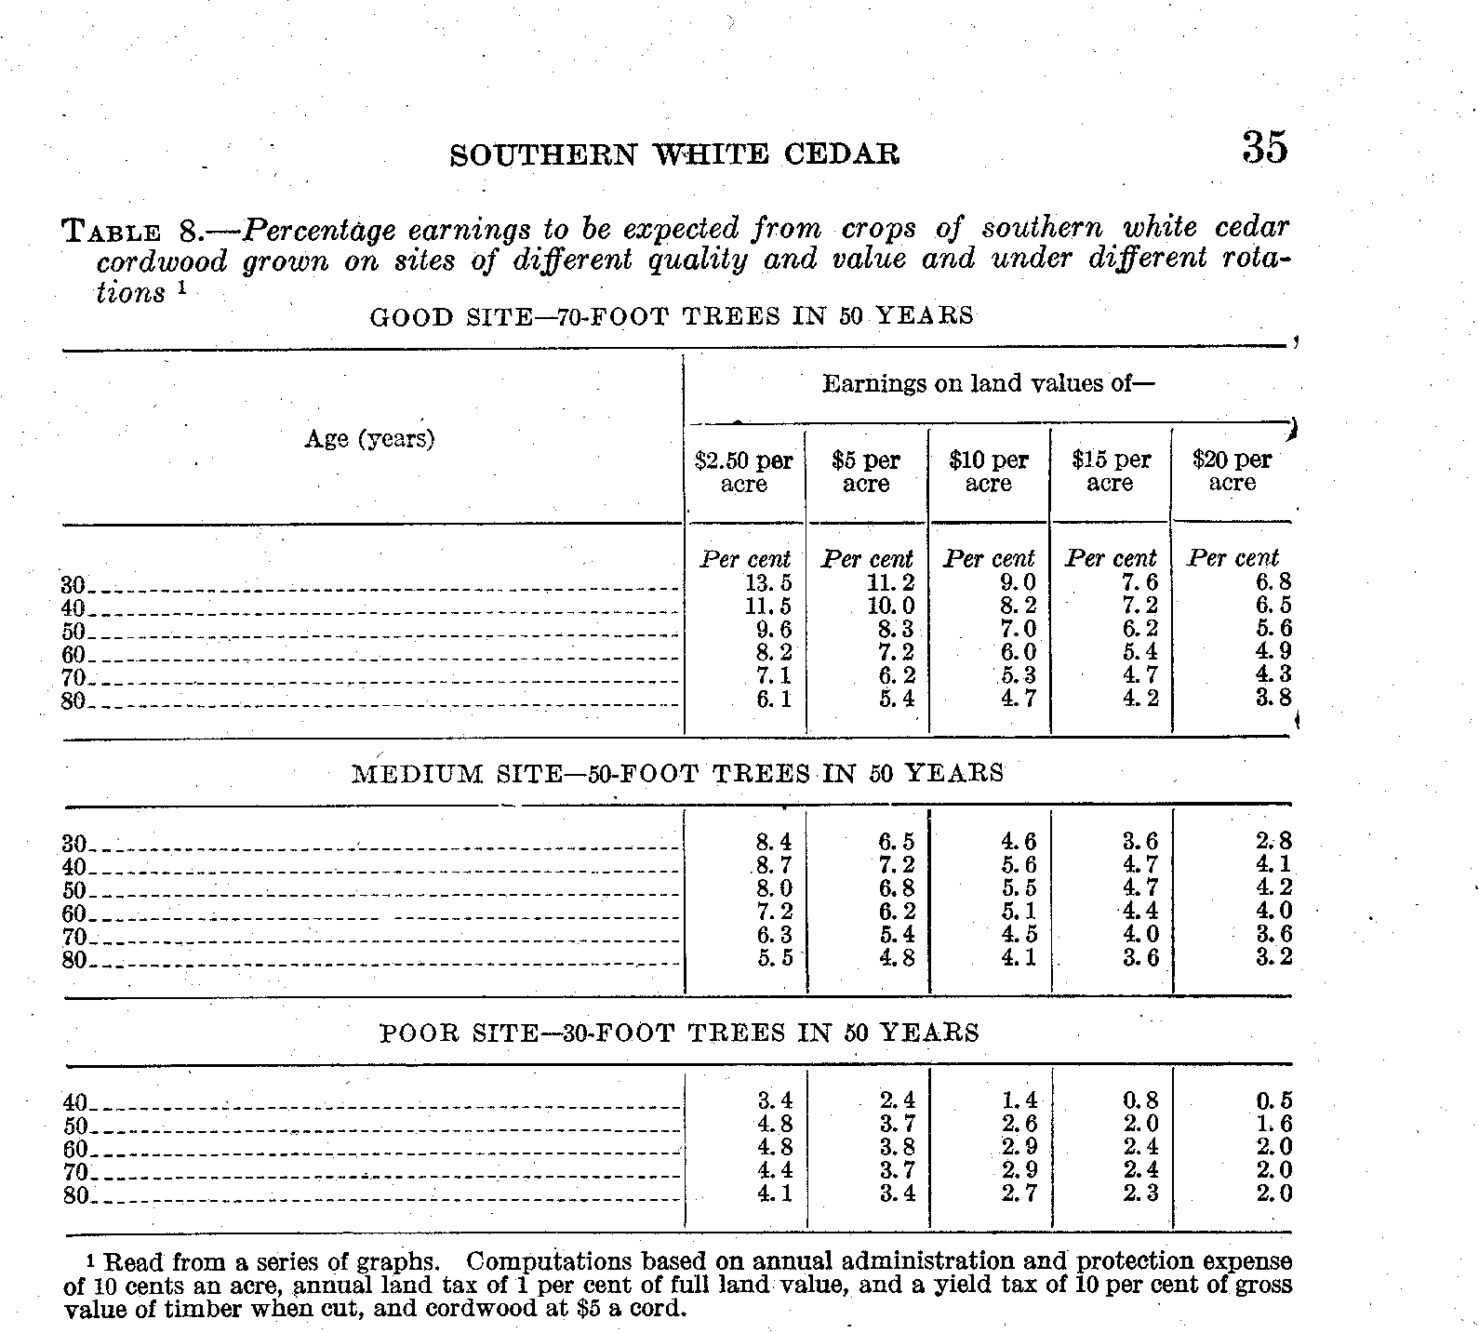

With land valued at $5 an acre and capable of producing 50-foot trees in 50 years, cordwood at $5 a cord, protection and administration at 10 cents an acre, and a land tax of 1 per cent, the investment in the 50-acre tract is shown in the following tabulation.


