TECHNICAL BULLETIN 251, U. S. DEPT. OF AGRICULTURE 36

ECONOMIC IMPORTANCE, PHYSICAL CHARACTERISTICS,
AND UTILIZATION OF THE WOOD¹¹
By W. D. BRUSH¹²

ECONOMIC IMPORTANCE

Southern white cedar reaches its best development in swamps where few other important timber trees thrive, and the occurrence of cedar stands gives value to many swamps which otherwise would be practically worthless. The excellent properties of the wood make it of special value for many purposes, principally boats, tanks, planing-mill products and millwork (including siding and finish), and boxes and crates. In addition to its durability, light weight, and ease in working with tools, the very gradual taper of the tree

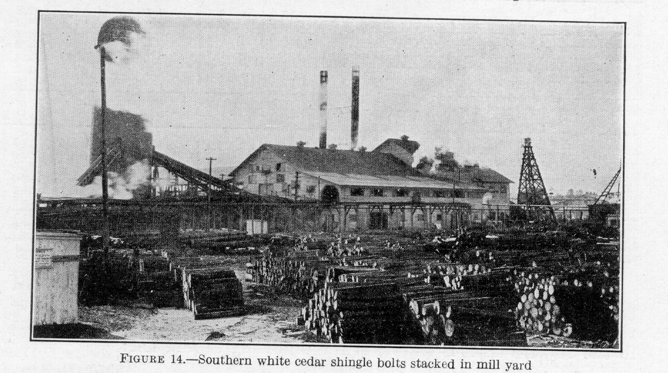

makes it valued for poles, dock shores, posts, and stakes. For over a century it has also supplied a local demand for such commodities as shingles and wooden-ware.
In boat building, one of its most important uses, southern white cedar is preferred for planking especially, but also for deck and cabin construction, for rowboats, lifeboats, motorboats, and yachts. Boat boards bring as much as $100 a thousand board feet at the sawmill and $120 from lumber dealers. Unusually large boards of high quality and clear of defects have sold for as much as $250 a thousand board feet.
The importance of southern white cedar is thus not dependent upon a large annual output but upon the qualities of the wood which adapt it for special purpose.
Good stands of cedar in New Jersey bring $150 an acre, and swamp lands bearing heavy stands have been known to sell as high as $400 to $800 an acre. Similar high prices have been received for the
¹¹ The prices given I this section apply more particularly to the period 1925-1929
¹² Acknowledgment of indebtedness is made to Eloise Gerry, microscopist, and G.E. Heck, engineer in forest products, Forest Products Laboratory, for their contributions to this part of the bulletin.
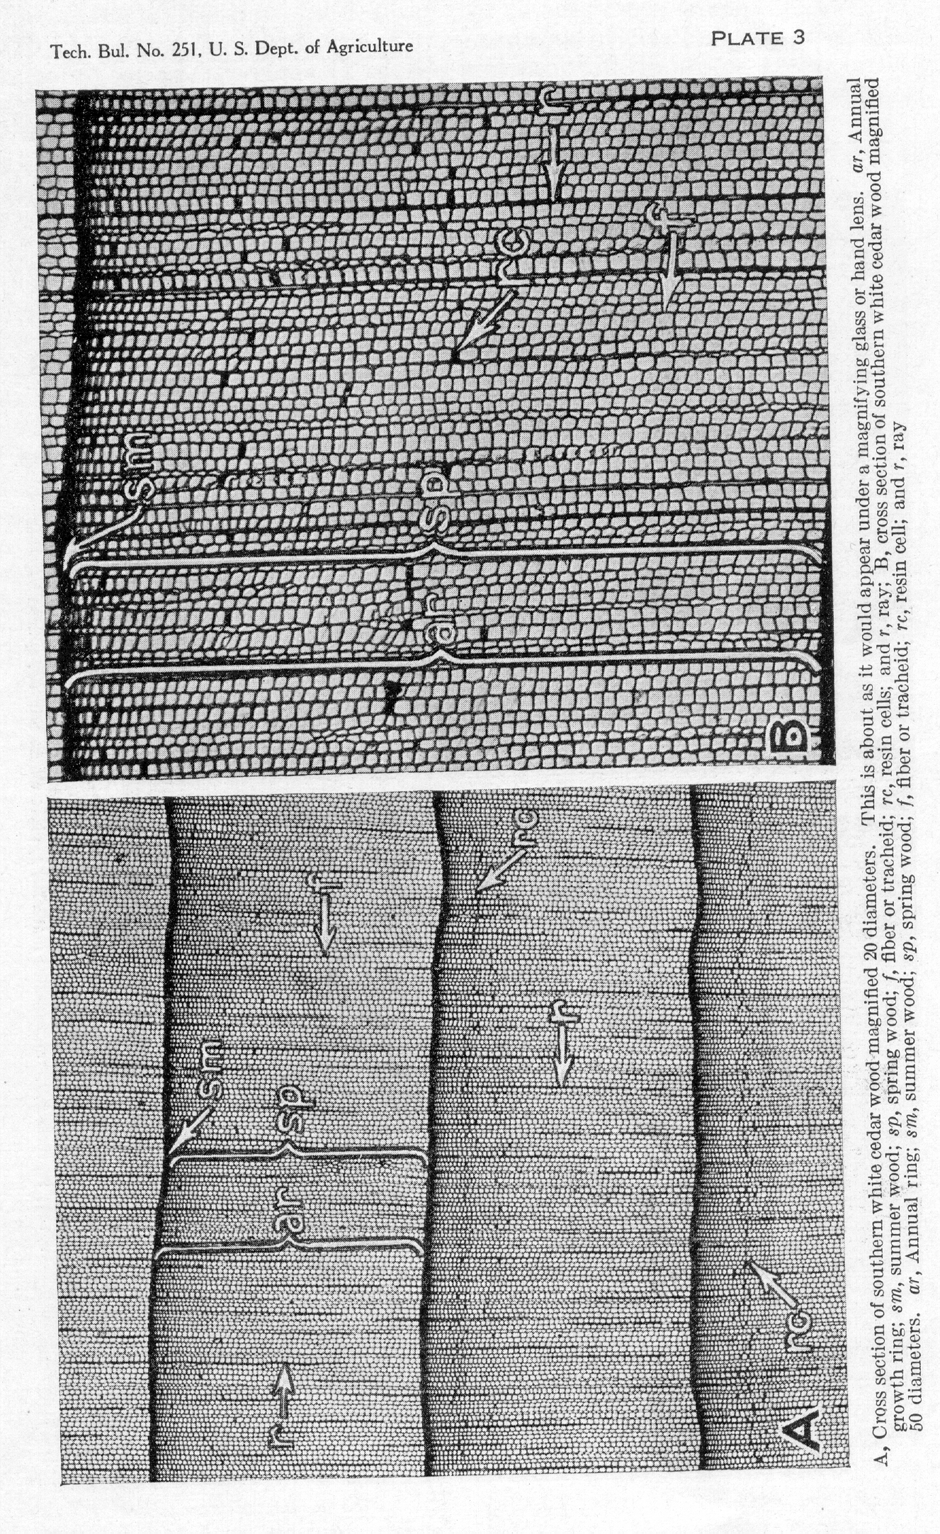
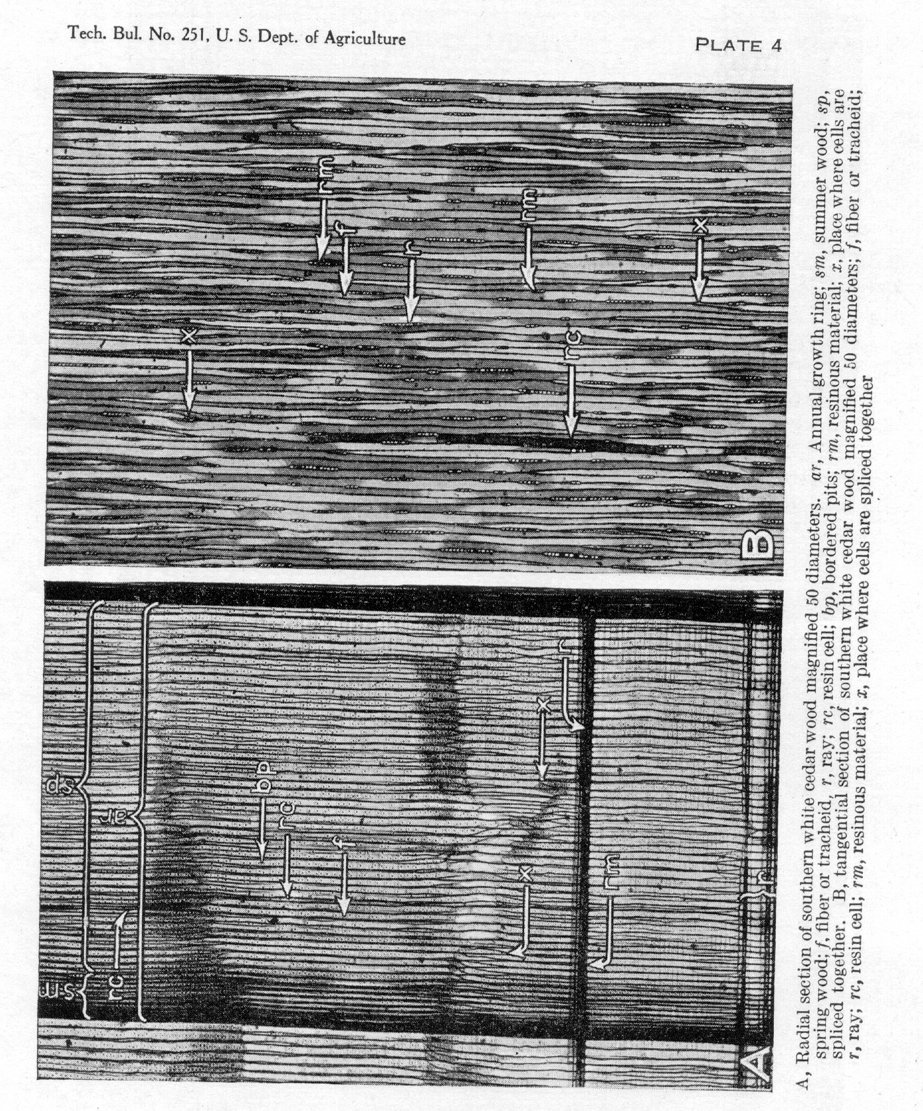
SOUTHERN WHITE CEDAR 37

better stands of this species in eastern Virginia and North Carolina. The value of the bare land alone has usually been placed at not over $10 an acre. In Southern New England prices for standing trees suitable for boat boards 12 inches and more in diameter are about $6 a cord, and logs at the mill bring about $16 a cord. In Virginia and North Carolina the usual price of cedar stumpage has been $8, to $10 a thousand board feet for the past several years. Cedar 8 inches in diameter and less, suitable for posts and rustic poles, brings about $2 a cord. Because of the intrinsic value of the wood and its growing scarcity these prices for southern white cedar seem likely to increase.
The cut varies greatly from year to year, depending largely on the market. The total in any one year must be estimated from records for lumber, shingles, lath, woodenware, poles, posts, and stakes of various kinds. Totals for some of those uses are not adequately reported, and for those classes for which reports are available the quantities are often combined with data for other species of cedar. Census reports combine all the species of cedar in one group. Also, southern white cedar is largely cut by small mills, many of which the census does not include. So far as possible these difficulties were overcome in the computation of Table 9, where total cut for the entire commercial range, divided into four fairly distinct regions, is expressed both in terms of cubic content of the logs and in number of board feet of lumber that could be sawed from the logs. The board-foot estimate excludes all the material that is too small for the manufacture of lumber.

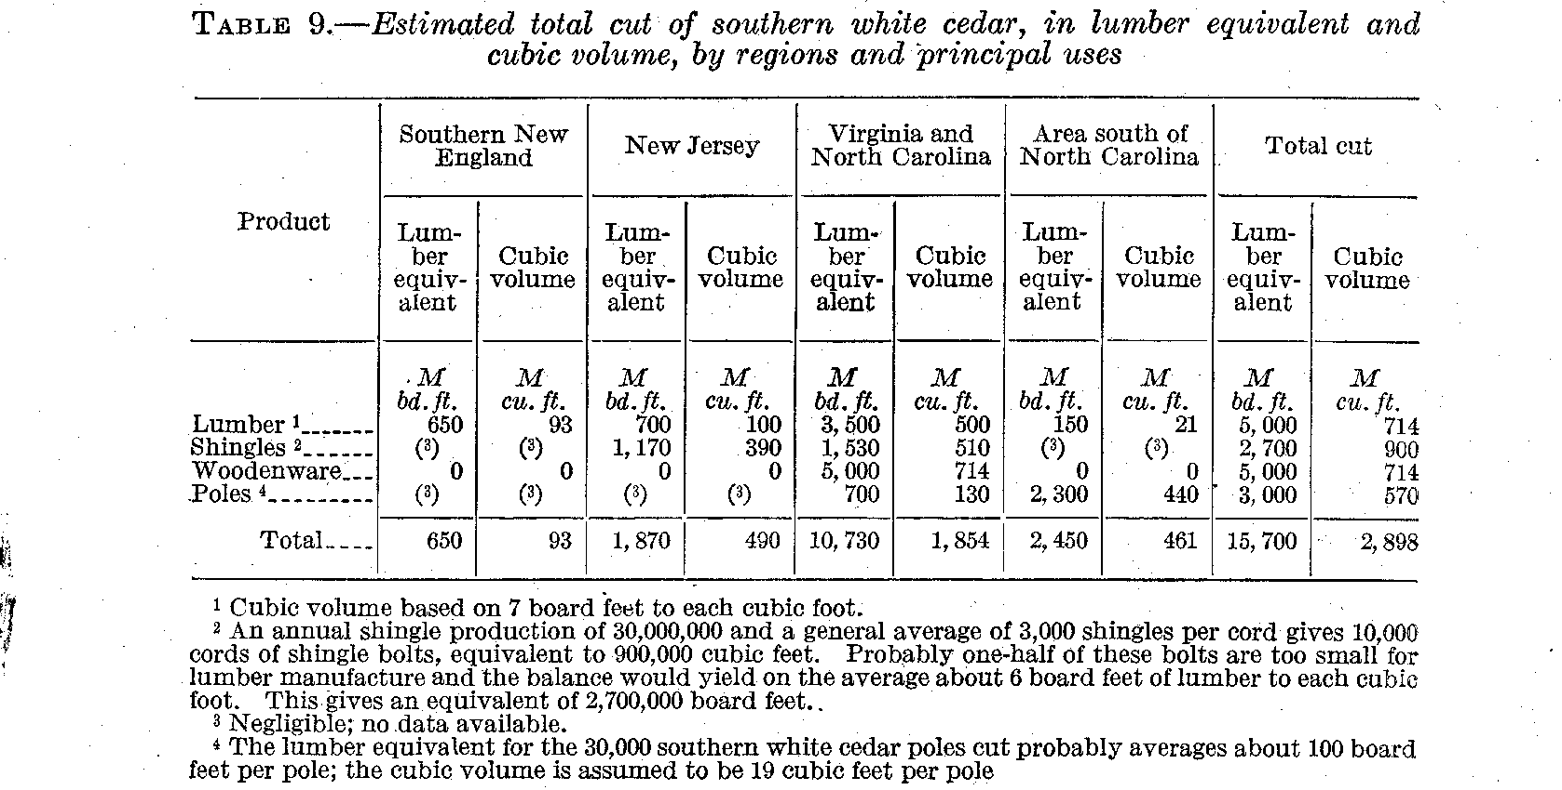

Lumber reported as "cedar" from the localities known to produce little or nothing except southern white cedar was segregated, and to this, as a basis for computation, data on the cut of a large number of plants too small to be included in census statistics were added. Census statistics on shingle production do not distinguish between the various kinds of wood. Practically the same procedure was followed, therefore, as for lumber. Figures on lath were not obtained, as lath is sawed largely from waste and small timber, and the total

TECHNICAL BULLETIN 251, U. S., DEPT. OF AGRICULTURE 38

is small. Data on the production of woodenware and similar products cut directly from the log and not from lumber were taken from statistics collected by the Forest Service on quantities of different kinds of wood used in manufacture in 1928 and were checked by field data. Bureau of the Census statistics were employed in estimating consumption of southern white cedar poles by railroads and electric-light, telephone, and telegraph companies. Statistics on the production of fence posts and smaller products, such as shadetree stakes and beanpoles, are unobtainable, although these products are important in some sections.
In New Jersey and southern New England, where the stands are comparatively small and scattered and the trees are generally small, there is a very active local demand for cedar products such shingle lath, siding, porch lumber, and other building material. Boat boards made on special order are sawed from the largest logs. A few posts and telephone poles are also cut. Large quantities of rustic poles, shade-tree stakes, bean poles, and other products are produced from small trees. Sawmills cutting cedar in this region are small and generally scattered throughout the cedar-swamp areas. Many of these mills, are portable and are operated by gasoline engines so that they can be moved mote readily from place to place as the merchantable timber becomes exhausted.
In Virginia and North Carolina, where the timber is larger and more plentiful and the stands are usually extensive, a few large mills cut much of the cedar lumber produced. Comparatively large quantities of shingles are produced here, as well as many telegraph, telephone, and electric-light poles.
Farther south in the Atlantic and Gulf coastal region there is a greater demand for cedar poles, for which southern white cedar is utilized almost exclusively. The butts of large trees are occasionally converted into shingles, but it is generally found more profitable to utilize the entire tree for poles whenever possible.
Keen competition for raw material occurs between some of the cedar industries. The pole industry, for example, competes with the manufacture of lumber and shingles, although both products are made from material much of which is too small or otherwise unsuited for pole stock. This competition exists mainly in North Carolina, where there is considerable large-sized cedar suitable for several different kinds of products. The lumber and shingle industries also compete, although much timber used for shingles is too small for lumber manufacture. In some mills shingles only are produced, and material too small for shingle manufacture is cut into lath.

PHYSICAL CHARACTERISTICS
STRUCTURE¹³

The wood of southern white cedar is classed as a softwood both because of its actual softness and because it has the structural characteristics of the softwood group, that is, the wood lacks the pores or vessels, the relatively large sap-conducting cells, which are characteristic of the hardwoods, and it is in this sense termed a nonporous wood. The structure is illustrated in Plate 3, A and B, by photographs of thin sections of the wood as they appear under the microscope.
—————————————————————————————————————————————
¹³ Prepared by Eloise Gerry, microscopist, Forest Products Laboratory.
SOUTHERN WHITE CEDAR 39

The wood of southern white cedar is light, soft, comparatively weak, fine textured, and usually has an even, straight grain. It has a slightly spicy, aromatic fragrance when freshly cut. When a smoothly cut cross section is examined it is possible to see with the aid of a magnifying glass or even sometimes without one-concentric rings of resin cells such as are shown at r c, Plate 3 , A and B. It is largely the volatile material contained in these resin cells which gives the wood its characteristic odor.
The heartwood is light brown tinged with red or pink. It is more pinkish in hue than the wood of northern white cedar or arborvitae (Thuja occidentalis). The sapwood is lighter in color (whitish) than the heartwood.
The growth rings (pl. 3, A, a r) are moderately wide, considerably wider on an average than those in northern white cedar. The summer wood (pl. 3, A, sm) is thin and appears as fairly conspicuous dark line-, bounding the growth zones. The spring wood, (pl. 3, A, sp) with its larger, thin-walled cells, makes up the greater portion of each year's growth.
The rays (pl. 3, A and B, r), which conduct food materials from the inner bark into the wood, are very numerous and fine, being only one cell wide in this species. Resinous material is often stored in the ray cells as well as in the vertical resin cells. This material is shown as dark areas in the rays in Plate 4.
So-called resin ducts or relatively large intercellular spaces containing oleoresin, such as are found in the pines, are lacking in the southern white cedar.
The fibers or tracheids (pl. 3, A and B f), which make up the greater part of the wood are relatively long, narrow cells with somewhat pointed, closed ends. The water and mineral matter from the soil pass up through the sapwood tracheids to the leaves. The manner in which these cells are spliced together is shown at x, Plate 4, A and B. The path of the sap from cell to cell is through pits or thin areas in the cell wall. These are shown at bp in Plate 4, A. These so-called bordered pits act as minute valves in the cell walls. In the softwoods, such as cedar, the fibers or tracheids serve two purposes, namely, sap conduction and mechanical support. In the hardwoods, on the other hand, there is a division of labor, and the pores or larger cells with open ends are especially adapted for sap conduction and the fibers for mechanical support.

PHYSICAL AND MECHANICAL PROPERTIES ¹⁴

Woods are classified by the Forest Products Laboratory into 10 grades, according to their physical and mechanical properties. . For example, for one property, as strength of a beam or post, a species is described by one of the following terms: (1) Extremely strong, (2) exceedingly strong, (3) very strong, (4) strong, (5) moderately strong, (6) moderately weak, (7) weak, (8) very weak, (9) exceedingly weak, and (10) extremely weak. According to this system of grading, southern white cedar is classified as light in weight, very weak in strength as a beam or post, moderately soft, low in shock-resisting ability, limber and small in shrinkage.
——————————————————————————————————————————————————————————
¹⁴ Prepared by G.E. Heck, engineer, Forest Products Laboratory.
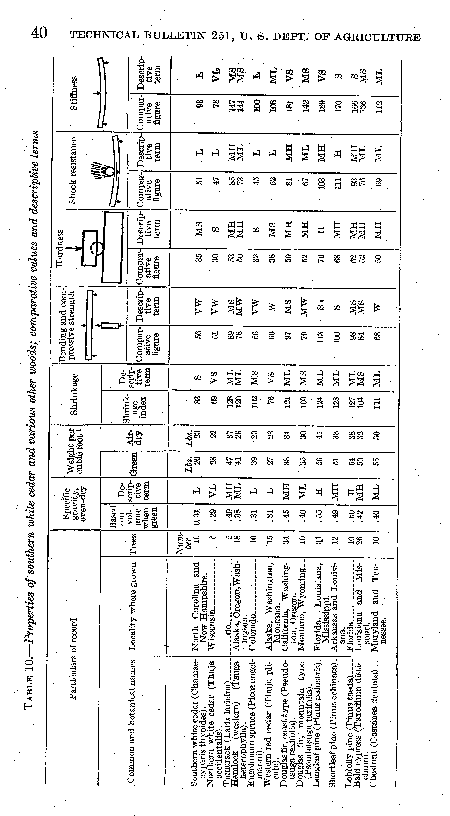
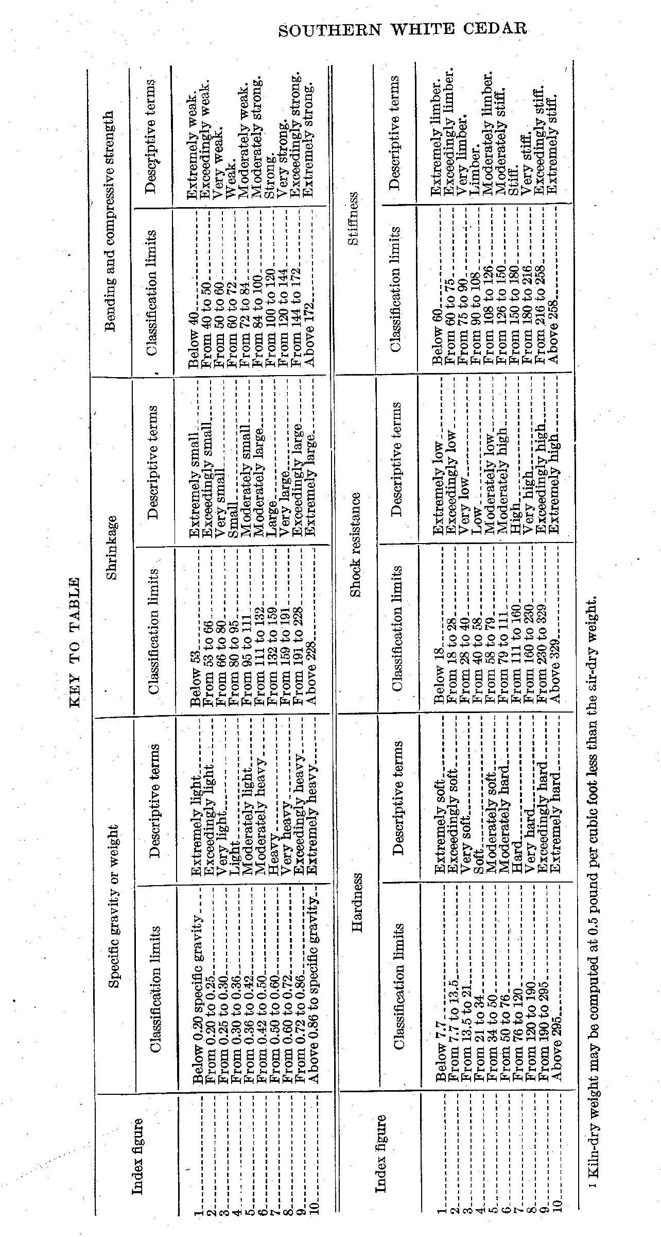
TECHNICAL BULLETIN 251, U. S. DEPT. OF AGRICULTURE 42

Table 10 gives comparative strength values and descriptive terms for southern white cedar and a few other species generally used for similar purposes. These comparative values were determined from a large number of tests on each species and are a combination of several kinds of tests. Each of the comparative values given in the table is a weighted average of several values derived from different kinds of strength tests. For instance, strength as a beam or post is a combination of values derived from tests in static bending, impact bending, and compression parallel to grain.
Compared on the basis of the grouping in Table 10, southern and northern white cedar are about equal in weight, shock-resisting ability, and shrinkage. Southern white cedar has about 10 per cent greater strength as a beam or post, is about 17 per cent harder, and has 19 per cent greater stiffness than northern white cedar. It is lower in all its properties than chestnut, but in comparison with western red cedar has about the same weight, hardness, and shockresisting ability, 18 per cent less strength as a beam or post, 17 per cent less stiffness, and 9 per cent more shrinkage.
The wood is usually straight grained, splits very easily, and is readily worked with ordinary woodworking appliances.
Table 11 gives average strength values for green and air-seasoned sothern white cedar, which are comparable to data on other species given by Newlin and Wilson (6).

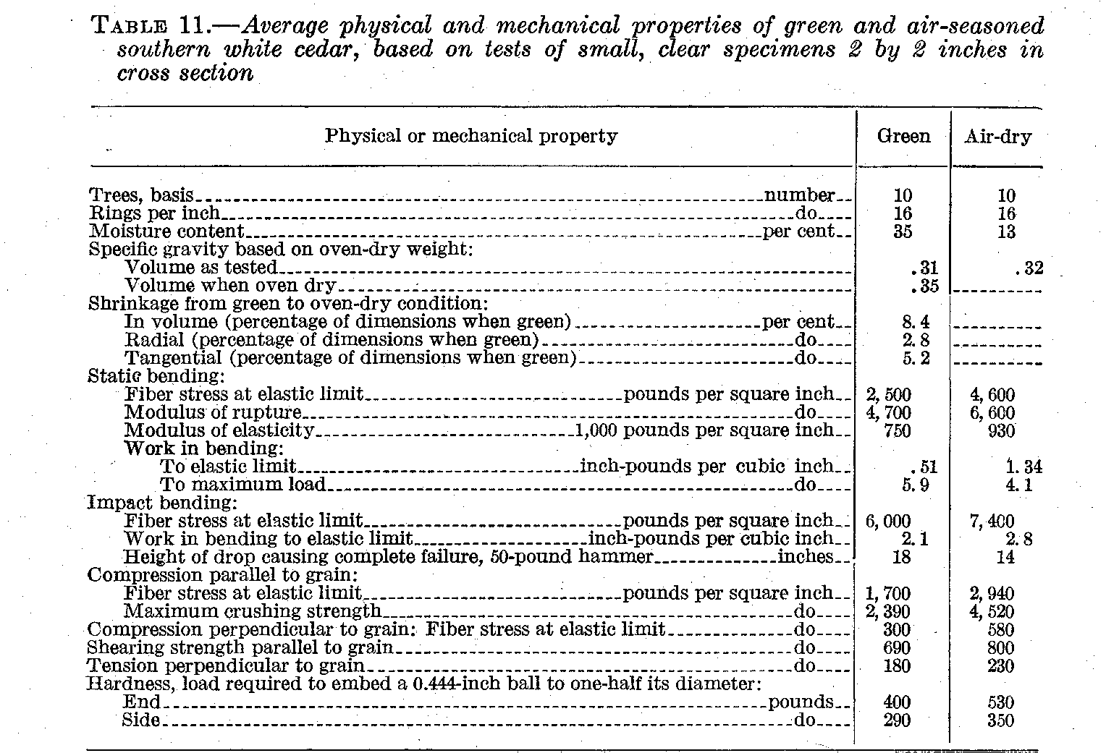

DURABILITY¹⁵

Southern white cedar is very durable when used in contact with the soil or under other conditions favorable to decay. In this respect it compares favorably with dense southern yellow pine, dense Douglas
¹⁵ Prepared by G.E. Heck
SOUTHERN WHITE CEDAR 43

fir, white pine, tamarack, and white oak. It is considered more durable than hemlock, the spruces, yellow poplar, loblolly pine, lodgepole pine, gum (sweet, black, and tupelo), the true firs, and basswood; it is probably somewhat less durable than southern cypress, redwood, chestnut, and most of the other cedars. Individual timbers of the same species may differ considerably in their durability, according to the amount of heartwood and sapwood they contain and their condition when placed in service. The heartwood is so durable that logs buried deep in the swamps for 50 years or longer furnish excellent lumber. More than a quarter century ago the mining of southern white cedar logs buried in the swamps was a profitable industry in New Jersey.

UTILIZATION

LUMBER

As already stated, southern white cedar lumber is manufactured under a variety of conditions, usually by small mills. Although there are no commonly accepted grades for logs, two classes sometimes are specified: No. 1, which allows small knots only; and No. 2, which is low grade and contains many defects. Southern white cedar lumber is characterized by many defects, particularly knots and wind-shakes. Log-run lumber (mill culls out) brings about $50 a thousand board feet wholesale.
The most important sawmill products are planing-mill products and millwork, tank stock, and boat boards. Some boxes and crates and fencing, including fence pickets, are also made.
The annual cut of 5,000,000 feet of southern white cedar lumber is utilized as follows:

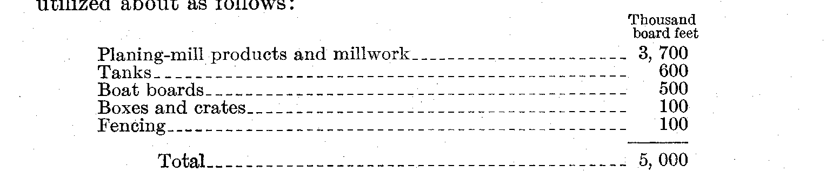

Siding is often in good local demand and forms an important product sawed from southern white cedar logs. Three grades are usually, specified-No. 1, No. 2 , and No. 3, or cull. No. 1 is designated as sound and permits small, sound knots; No. 2 has somewhat larger knots and some wane; No. 3, or cull, is very defective. No. 1 grade brings $50 to $60 a thousand feet at the mill for boards 6 inches wide; No. 2 grade, 6 inches wide, sells for about $30 at the mill; and the cull commands about $18. Stock 5 inches wide is generally priced $5 to $10 less a thousand feet than 6 inch material, and 4 inch widths bring proportionately less. Prices for siding delivered are about $10 a thousand more than at the mill. Other kinds of finish, such as general millwork and material for porches, are produced in considerable quantities. Porch lumber is sound, tight-knotted stock and is sold for about $70 a thousand feet for 5 and 6 inch widths. It may sometimes be purchased for as low as $60 at the sawmill.
Flooring is sometimes manufactured of southern white cedar. This stock usually measures 1 by 6 inches by 8 feet and is surfaced on only one side small, tight knots up to three-fourths inch in diameter are allowed. A good grade of flooring may sell for as much as $100 a thousand board feet.
TECHNICAL BULLETIN 251, -U. S. DEPT. OF AGRICULTURE 44

Considerable quantities of southern white cedar are used in the manufacture of water tanks, because of the lightness and durability of the wood. Tank stock is 1 1/2 to 4 inches thick usually 2, 2 1/2 and 3 inches and is produced from large-sized timber. Tank stock must be watertight, but there is no objection to sound knots. It brings about $60 or $65 a thousand board feet.
Boat boards are manufactured as round-edge lumber and are sawed with the "sweep" of the log, so that the boards are curved and can thus be adapted to any desired form for small boats. They must usually be at least 6 inches wide at the narrow end, and usual thicknesses are 4/4, 5/4, and 6/4 inch; in southern New England, however, 5/8 of an-inch is a common thickness. In North Carolina there are generally two grades of boat boards: No. 1, called clear stock, permits as many as three tight knot, l 1/4 inches in diameter in a 16-foot board; No. 2, called knotted stock, permits any number of sound, tight knots but no other defects. The knots must not be so large as to impair the strength of the board. Loose and unsound knots must run at right angles to the surface of the board so that they can be bored out and plugged. In New England and New Jersey, boat boards are sawed by small mills, generally on special order only. They are the highest class of stock, and there is but one commonly accepted, grade, in which only small tight knots are permitted. This grade usually brings about $100 a thousand board feet but sometimes sells for as low as $80 a thousand. Stock of more than usual width and length may bring considerably more. No. 2 grade, where accepted, generally sells for about $70. Decking for boats is sound, tight-knotted stock. It is 1 to 2 inches thick and sells for about $60 a thousand board feet.
Southern white cedar is valuable for the construction of small boats. During the World War 2,500,000 board feet of "white cedar," probably all of which was of this species, was used by the United States Navy in boat building.
On account of its light weight, involving low transportation costs, cedar lumber is also in demand for boxes and crates, especially in localities where vegetables and small fruits are grown in large quantities. Such fruit and vegetable crates are built up of narrow strips or slats, and thus small and defective cedar timber can be used to advantage in their manufacture. Crate slats are mostly about 16 inches long and bring about $2.75 for 100 pieces. The price paid for the crates, however, varies greatly from year to year, depending on the condition of the crops and the available supplies of other crate material.
Southern white cedar is used in a small way for fencing. In the form of boards it is usually sold as No. 1 fencing. This is low-grade stock, equivalent to the No. 2 common grade of ordinary lumber, and sells for about $30 a thousand board feet. Pickets for woven-wire fencing, made from waste in lath manufacture, are one-half inch thick, 2 inches wide, and 4 feet long, and generally sell for $12 to $15 a thousand pieces.
Other occasional uses for southern white cedar lumber include ferry decking, pattern stock for foundries, and the manufacture of coffins and caskets. Lumber 2 inches thick is sometimes used in the manufacture of built-up decoys.
SOUTHERN WHITE CEDAR 45

SHINGLES

For shingles, lightweight and durability are the qualities which give southern white cedar a comparatively high value. Bolts for the manufacture of shingles should be at least 4 1/2 inches in diameter at the small end. The length of bolt varies with the length of the finished shingle. In North Carolina, where the usual shingle length is 20 inches, bolts are 5 feet 2 inches in length. (Fig. 14.) Bolts 5 1/2 inches and more in diameter are slabbed on two opposite sides; those under 5 1/2 inches on only one side. They are then sawed off square at the ends and cut into three lengths of 20 inches each. These short lengths go to the shingle saw, after which the round-edge shingles are squared by sawing. They are packed in bundles of 50, 25 on each side. Other common shingle lengths are 18 and 24 inches, and less common lengths are 16 and 22 inches. Shingle widths are 3 3/8, 4, 5, and 6 inches.
Table 12 gives the yield of southern white cedar shingles from bolts of different sizes. The output of shingles per cord of logs varies at different mills, depending on the size of shingles and method of utilization. In New Jersey, where the 4 by 24 inch shingle is considered the standard size, a yield of 2,200 to 2,500 shingles per cord of 128 cubic feet is reported. For different-sized shingles the yield is as follows: 4 by 16, 3,700 to 3,800; 4 by 18, 3,500; 4 by 24, 2,300.

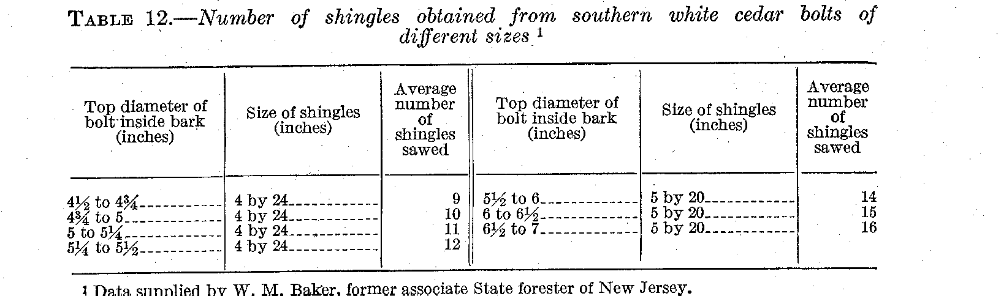

In North Carolina a general average of 3,000 shingles 20 inches long in all widths from 3 3/8 to 6 inches is obtained from each cord of logs and bolts. The number of cubic feet per 1,000 shingles has been calculated as follows for different sizes: 3 3/8 by 20 inch 12.75; 4 by 20 inch, 15; 5 by 20 inch, 19; 6 by 20 inch, 22.6. The 4-inch and 5-inch widths are most common, and each cord must therefore produce 45 to 57 cubic feet of shingles. Since each cord contains between 80 and 90 cubic feet of solid wood, the waste, including saw kerf, amounts to 30 to 50 per cent. Some of this waste in the form of slabs is utilized in the manufacture of lath.
Grades and specifications for southern white cedar shingles vary greatly in different regions. In the North the grades are generally designated a No. 1, No. 2, and No. 3., or cull. The No. 1 grade is practically all heartwood and sound, only small tight knots being accepted; No. 2 is sound and allows sapwood; No. 3, or cull, is defective and allows wane or bark on the edges.
In the North Carolina region the common grades in use are as follows: No. 1, A, Star, No. 2, and cull. No. 1 is a heart grade and permits one sound knot in the "point" of the shingle only. The A

TECHNICAL BULLETIN 251, U. S. DEPT. I OF AGRICULTURE 46

grade is clear of defects and allows sapwood. The Star grade allows small sound knots and sapwood. No. 2 allows larger knots, and cull permits many defects, including wane. Singles 3 3/8's inches wide are not separated into grades but are sold as "log run " at about $4.50 a thousand. The prices of the different grades and sizes vary greatly, as shown in Table 13.
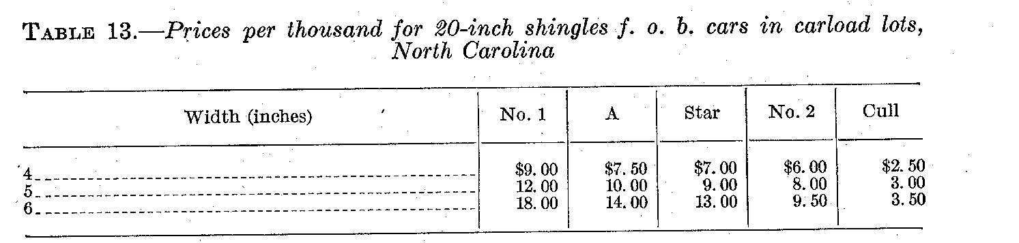

An average cedar-shingle mill in New Jersey will saw about 10,000 to 12,000 shingles a day, or 1,500,000 a year. Some mills find it, more advantageous to use gasoline power. A mill operated by a gasoline engine will cost about $3,000, as compared to $5,000 for a steam mill. The steam mill uses waste for fuel but is so much more difficult to move that for less than a 10-year operation the gasoline plant, is considered more practical.
Another North Carolina schedule of prices and grades, specifying 4 by 18 inch shingles, in dollars per thousand at the mill, is as follows:

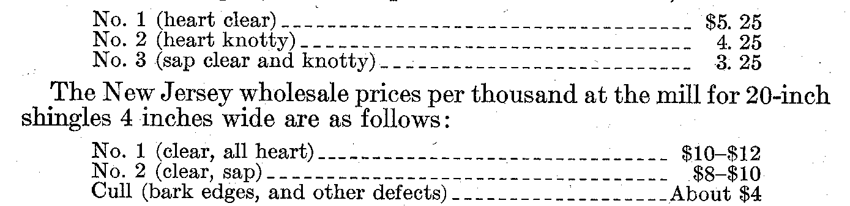

Prices delivered usually range from 50 cents to $2 higher, depending largely on the distance to which the mills deliver. Some mills cut 24-inch shingles. These sell for as much as $18 for No. 1, $12 for No.2, and $5 for cull at the mill. Some mills dispose of their product entirely at the plant and avoid the expense of hauling and loading on cars. The best grade of 16-inch shingles in southern New England brings $6 or $7 a thousand.
Some mills find it profitable to edge their cull shingles, which raises the grade but produces a narrower shingle. One man can edge about 5,000 shingles a day.

LATH

Southern white cedar is suitable for lath because it can be nailed easily and is not likely to warp. Lath is sawed from slabs and material too small for shingle manufacture. Lath bolts or "rails" are used down to a top diameter of 2 or 2 1/2 inches. They are 12 feet long and are sawed twice into 4-foot lengths. Two grades of lath are usually specified: No. 1, which is sound, square edged, and free from any knots that impair the strength, and No. 2 or cull, which has many defects, including knots, knot holes, bark, and wane.
SOUTHERN WHITE CEDAR 47

Manufacturers report a yield of about 2,200 lath to each cord of lath rails. On the basis of 70 cubic feet of solid wood to the cord, this gives about 50 per cent waste in the manufacture of lath. Table 14 shows the number of lath sawed from bolts of different sizes.

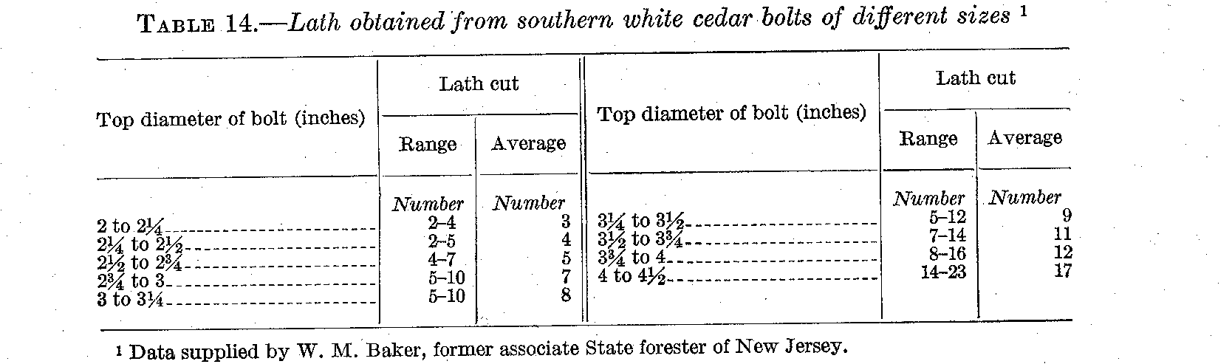

The price for No. 1 runs from $5 to $8 a thousand at the mill or f. o. b. cars, and of No. 2 from $2 to $4. Delivered prices are usually $1or $2 a thousand higher.
WOODENWARE

Use of southern white cedar for woodenware is confined mainly to the manufacture of tubs and pails of various kinds. Logs for this purpose are generally cut in 6 to 8 foot lengths. The stock is usually manufactured directly from the log because more can be got out of the log than from the lumber. Hollow logs and logs with decayed centers, which would yield practically no lumber, may cut a considerable quantity of tub or pail stock. Logs are sawed, into short bolts from which staves are cut by a cylindrical stave saw, and bottom pieces are cut from lumber sawed from similar bolts. The staves are given a slight tongue and groove along the sides and are grooved on the inside near the lower edge to receive the bottom. For ice-cream packing tubs, which must be light in weight and durable, large quantities of southern white cedar are used. To withstand rough handling these tubs are made with a double bottom, the lower piece flush with the lower end of the staves. Common washtubs, tubs for washing machines, and churns and pails are also made of this wood.

POLES, SHORES, AND SPARS

Southern white cedar is in great demand for poles (mainly telephone and electric light) because the timber is straight, tapers slowly, is free of limbs for the greater part of its length, and is light in weight and durable. Since it is not so strong as many other -pole woods, such as long leaf pine and chestnut, it is not so suitable for long poles where sleet storms are prevalent, particularly where the poles must carry a large number of wires. The southeastern limit of the sleet region coincides roughly with the main line of the Southern Railway running southwest from Washington, D. C., to Atlanta, Ga., and marks the northern limits of the more general use of southern white cedar for poles. There is. however, an appreciable demand for southern white cedar poles in the North even as far as the Great Lakes region, where northern white cedar pole timber has become scarce. They are purchased principally by the smaller municipalities for carrying electric-light wires.
TECHNICAL BULLETIN 251, U. S. DEPT. OF AGRICULTURE 48

A large number of southern white cedar pole operations are found in the South Atlantic, States. After the trees are felled, trimmed, and peeled, they are pulled out of the swamps to higher ground and loaded on wagons or trucks. Stumpage is bought by the linear foot, the rate depending on the length of pole. The rate generally runs about as follows:
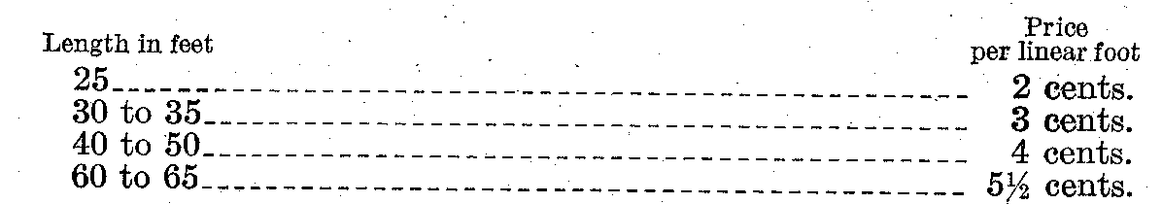
The average price paid for felling, trimming, and peeling is about 1 1/2 cents a linear foot. The cost, in the woods, of the average-sized pole (35 feet long to a 7-inch top) is therefore about $1.60. Its cost at the loading point is about $4.50. It is sold to the wholesaler or jobber for about $7.50. The freight on this pole at a 42-cent rate, which is a representative rate to points in Ohio, Indiana, and Illinois, amounts to about $2.50, making the total cost to the northern wholesaler about $10. The pole would retail for about $15.
The larger pole producers frequently purchase poles from small operators. Table 15 gives representative prices paid for different-sized poles loaded on cars. These prices represent an average increase of about 40 per cent from 1920 to 1925.
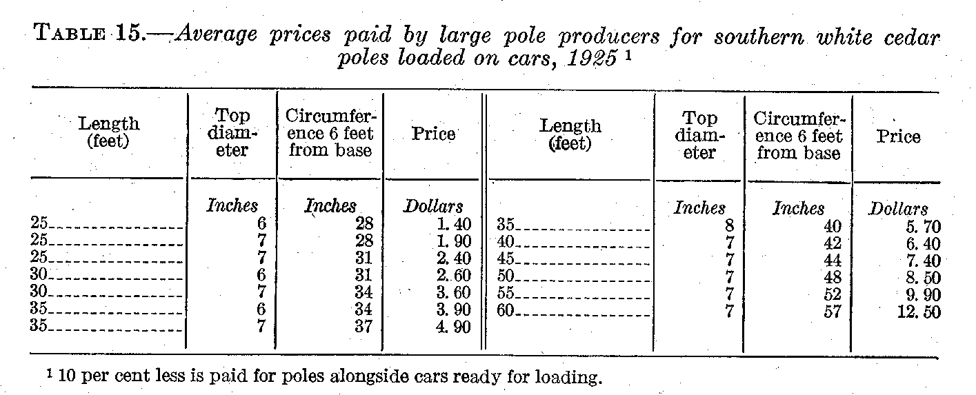
Freight

Freight costs on poles vary greatly with the size of pole and distance shipped. For instance, at a 25-cent freight rate the cost of shipping a 6-inch 25-foot pole is 63 cents, and at a 50-cent rate the freight on a 60-foot pole is $11 or $12. Average weights are given in Table 16.
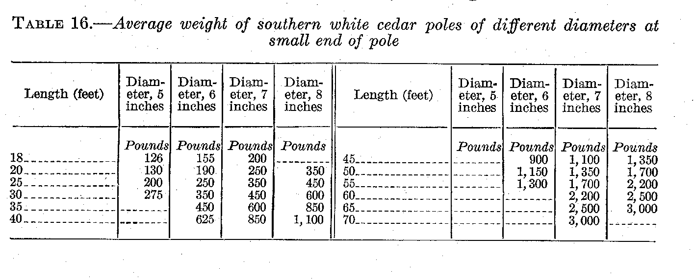
SOUTHERN WHITE CEDAR 49

The number of poles that can be loaded on a car is about as follows: 7-inch 30-foot poles, 100; 7-inch 35-foot poles, 75 to 80; 8-inch 35-foot poles, 65; 7-inch 40-foot poles, 65 to 70; 8-inch 40-foot poles, 60; 8-inch 50-foot poles, 50; 8-inch 60-foot poles, 40. (Fig. 15.) All poles over 40 feet long require two cars for shipment.
An increasing preference is being shown for treated southern white cedar poles. In this preservative treatment the butt of the pole, which is in contact with the soil and therefore most subject to decay, is placed in hot creosote for several hours, and then in a similar bath of cold creosote (3). it is claimed that a 3/8-inch penetration is obtained by this hot and cold bath open-tank treatment. A firm

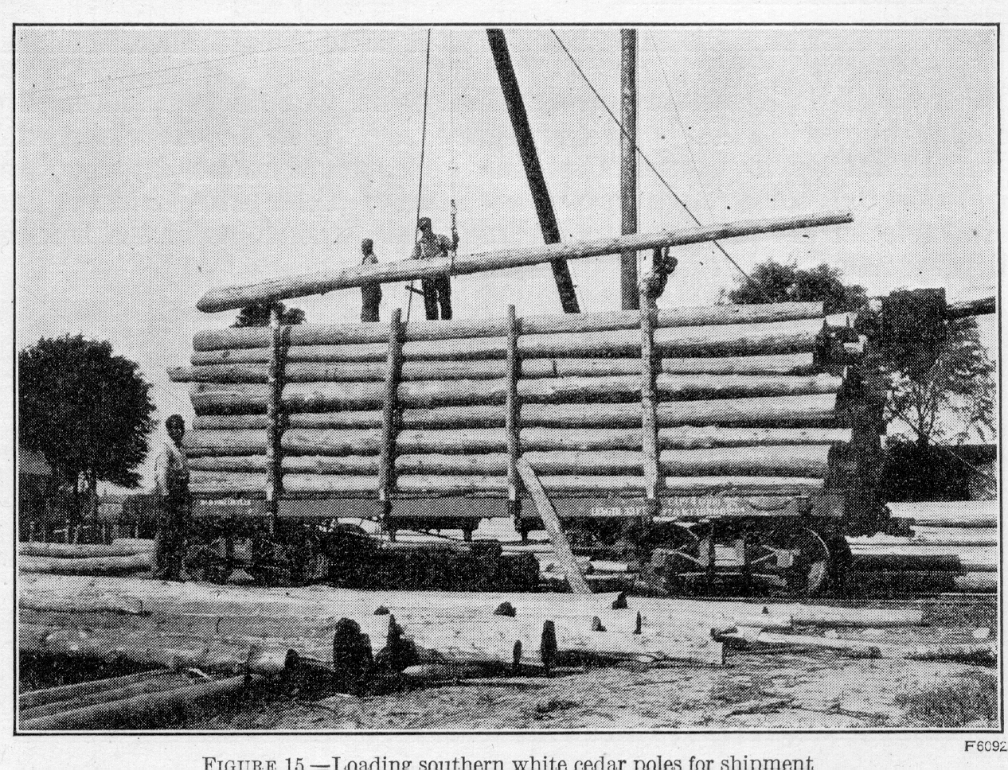

purchasing southern white cedar poles in large quantities and operating its own treating plant finds that the preservative treatment costs about one-half the price of the untreated pole and claims that the life of the pole is generally at least doubled by proper treatment.
During the past few years there has been a decrease in the demand for southern white cedar poles owing to the large use of treated southern pine poles.
Southern white cedar poles are used by the United States Navy Department as dock shores for shoring up boats when undergoing repairs in dry dock. These poles must be straight, sound, and free from shakes, split tops or butts, spiral growth, and large or unsound knots. Bark must be left on unless otherwise specified.¹⁶ The sizes specified are shown in Table 17.
¹⁶ Copies of Navy Department specifications may be obtained form the Bureau of Supplies and Accounts, Navy Department,
Washington, D. C.
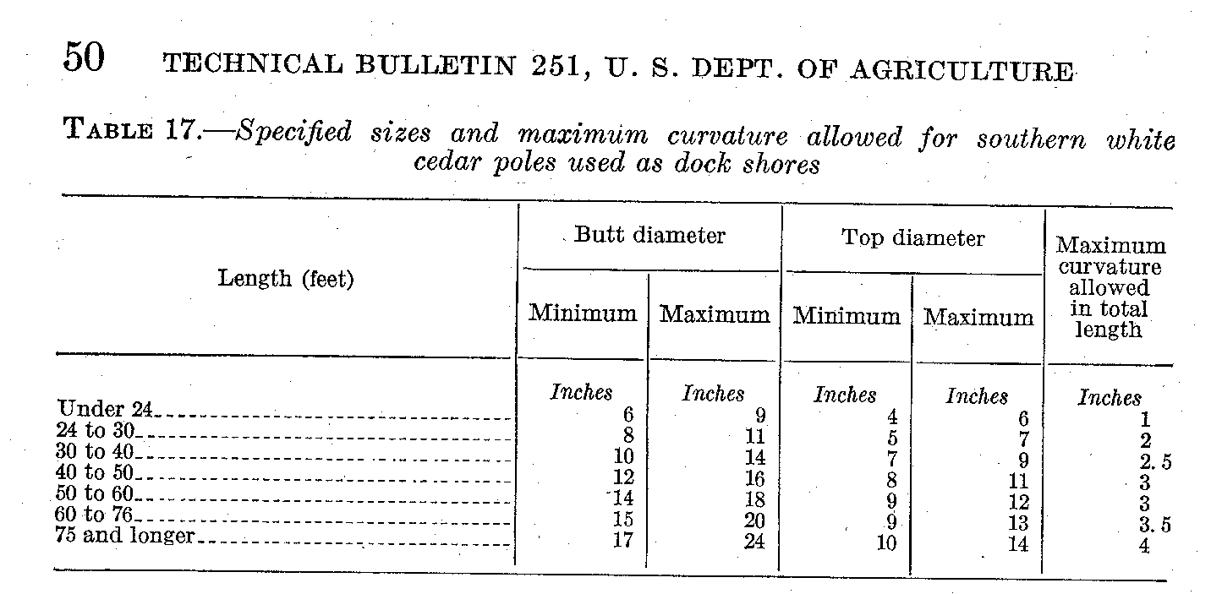

Because of its lightness and durability, the wood is valued highly for spar buoys. These spars are generally 25 to 50 feet long and about 12 inches in diameter at the butt and 8 inches at the top. Logs selected for this purpose because of their straightness and uniform taper are trimmed to the required dimensions in the woods, generally from timber of larger sizes.

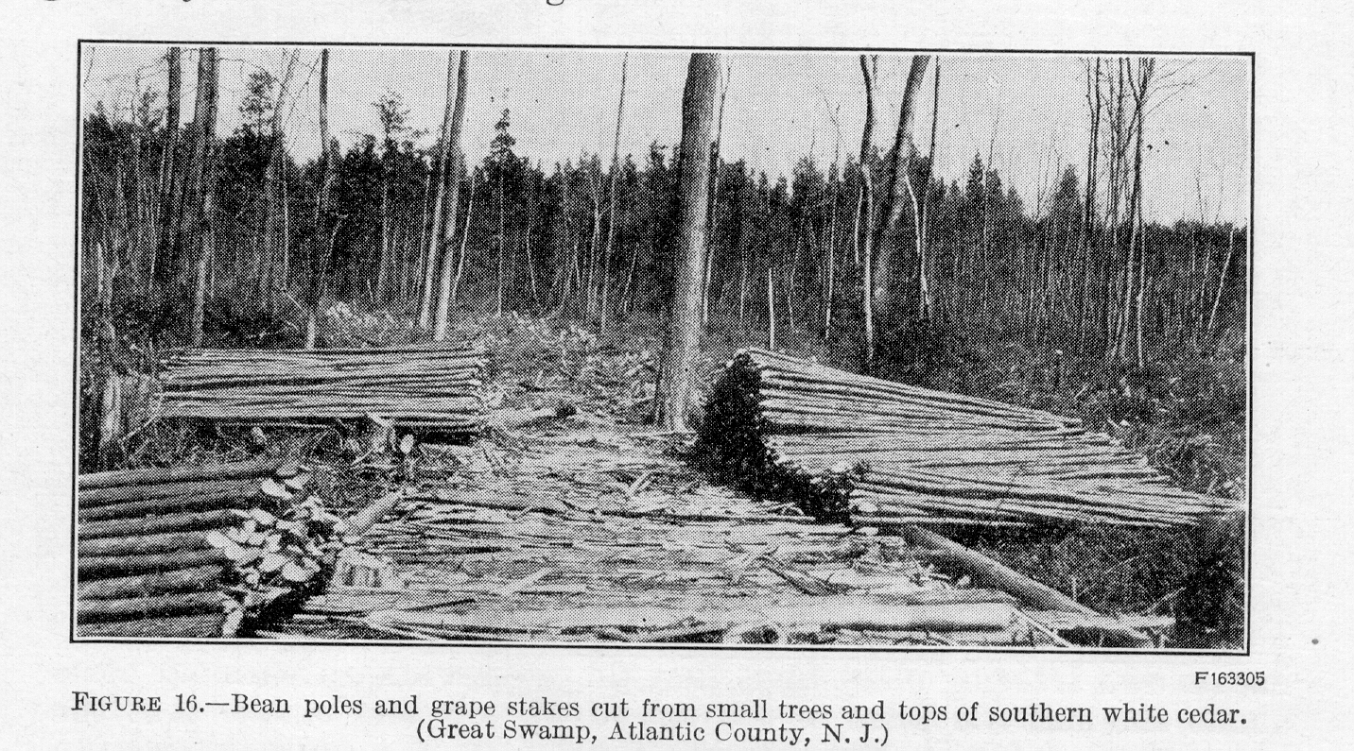

SMALL POLES, POSTS, AND STAKES ¹⁷

A market for small-growth southern white cedar will often make it possible to dispose of thinnings at a profit or at least at prices sufficient to pay most, if not all, of the costs of the operation. Thinnings suitable for special purposes, such as nursery poles, grape stakes, and arbor poles (fig. 16), will bring the best prices, but it may often be possible to dispose of less desirable material for such purposes as bean poles or rustic poles at a good-enough price to cover the cost of production-that is to say, the cost of thinning, hauling, and loading.
Fence posts are sometimes cut from southern white cedar. The usual dimensions are 4 to 7 inches in diameter at the top and 7 or 8
——————————————————————————————————————————————
¹⁷ Prices given were furnished by the department of conservation and development, division of forests and parks, State of N.J.
SOUTHERN WHITE CEDAR 51

feet in length,, They may be cut from the tops of trees used for poles or from small trees where shingle manufacture is not carried on. Seven-foot posts with a 5 to 6 inch top usually bring from 25 to 40 cents each, delivered. They sometimes retail for as much as 60 cents.
Table 18 gives approximate specifications, costs, and prices for small poles, posts, and stakes , estimated from a number of small operations in different localities. The cost and price may, of course, vary considerably under different conditions of production and sale. Table 19 gives the weights of unpeeled poles, stakes, and posts of different sizes.

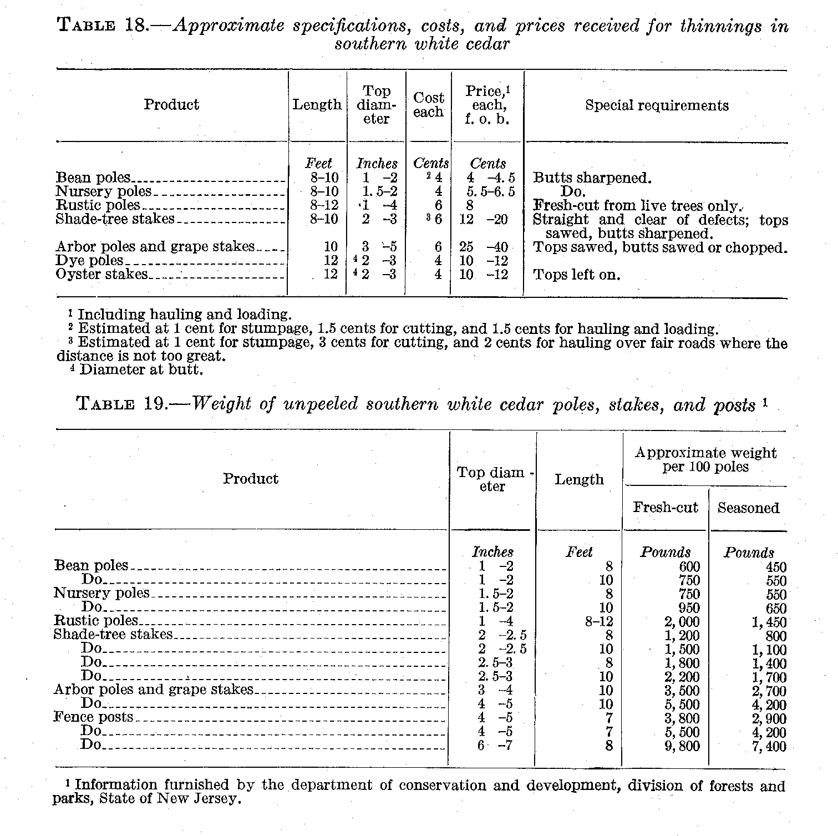

TECHNICAL BULLETIN 251, U. S. DEPT. OF AGRICULTURE 52

OTHER USES

Southern white cedar is suitable for cross arms because of its lightweight and durability. These are cut from clear, straight logs 4.5 to 8 inches in top diameter and 13 feet long, to make 6-foot cross arms.
Where cedar mills are located in or close to towns, slabs sold for fuel frequently bring from $4 to $8 a cord. The heating value of cedar is low, however, as compared with that of such woods as oak and beech. About 2 cords of cedar are required to equal the fuel value of 1 ton of coal.
Excelsior is a by-product of the cedar-shingle industry. It consists of the curled fibers which are produced by the shingle saw. This material is separated from the sawdust with a fork and pressed into bales weighing about 40 pounds each. These bales sell for 75 cents to $1 each where there is a demand for the material for packing glassware, china, and other fragile articles.

