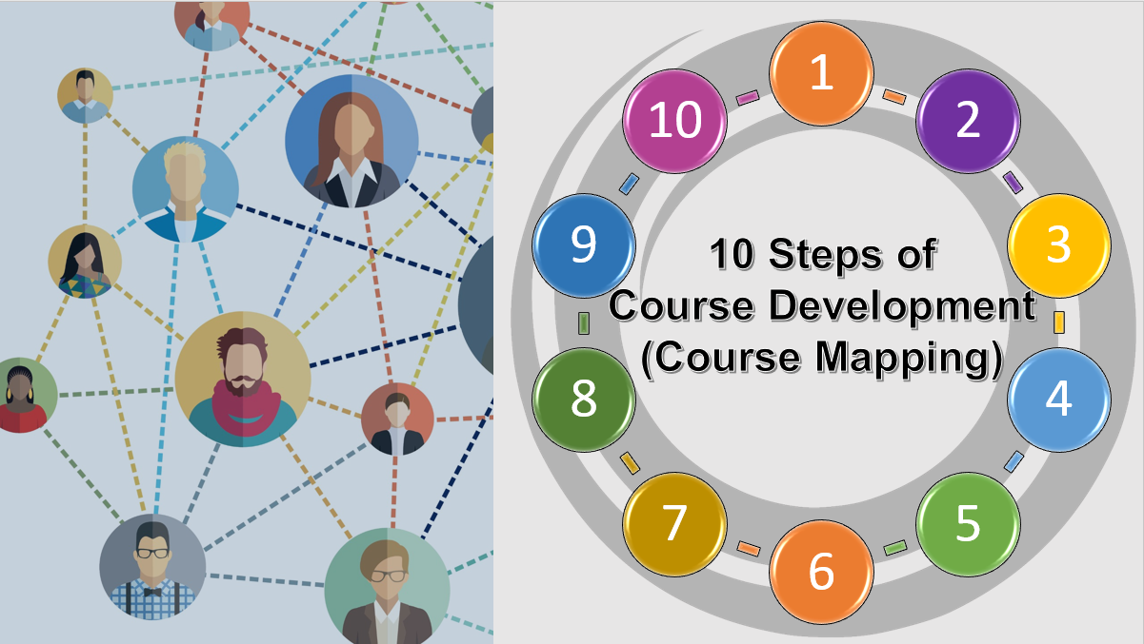
- Define Course Objectives [Based on Program Standards and Curriculum]
- Develop Student Learning Outcomes [Bloom’s Taxonomy]
- Determine Course Content [Meets Objectives and Outcomes]
- Select Teaching Methods [& Course Tools]
- Choose/Plan Assignments [Authentic, Explicit & Measure Learning]
- Select Materials [Textbooks & Digital Learning Tools - Consider OER]
- Define Course Policies
- Develop Course Schedule
- Create A Clear, Organized Syllabus [Reflecting You & The Course]
- Monitor Course Design & Plan in Action [Ongoing Assessment Process]
The steps of course mapping are most directly reflected in the following Quality Matters Higher Education Rubric Sections: Learning Objectives (Competencies), Instructional Materials, & Learning Activities and Learner Interaction.
Suggested Use: This worksheet is designed to assist you with making decisions and mapping out a course following best practices in course design. Complete this document for your online course. Additional resources are provided as hyperlinks in the document. Information from the course mapping activities below will be included in your course syllabus. Save and complete this worksheet.
COURSE MAPPING ACTIVITIES

Course Name:

General Course Description (copy from Course Catalog):

Course Objectives(s): Course objectives are statements defining what will be taught in a course. They indicate what students should learn in the course (faculty intent). These are derived from course goals, ELOs, program objectives or accreditation standards.
Ask yourself: What do students need to remember from your course in 5 years? What skills should students use and gain in this course? Consider how this course relates to other courses in the program/discipline. Is this course an introductory, intermediate, or advanced course?

Example of course objectives for a chemistry class:
- Teach chemistry topics (list the topics) that must be covered to help students prepare for other courses and for standardized exams.
- Teach study skills that students need to succeed in university-level science courses.
  - Teach students how to study effectively in a group.
  - Teach students how to manage time and complete ongoing drafts of projects
  - Teach students how to use chemistry software
- Teach students problem-solving and critical-thinking skills.
- Demonstrate how chemistry is used in other professions and everyday situations.
- Teach students to appreciate the beauty of chemistry.

Your turn: List Course Objectives for Your Course:

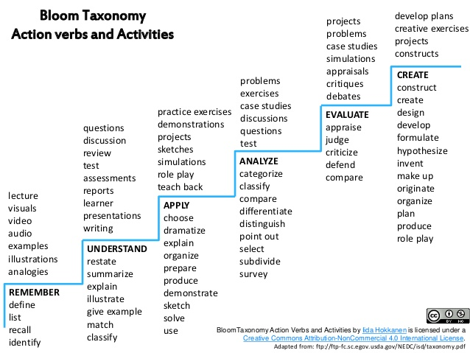
Verbs
Activities

Specific Student Learning Outcomes (SLOs): Create learner-centered SMART (Specific, Measurable, Achievable, Relevant & Time Component) outcomes for your course. SLOs are explicit, clear, observable statements indicating exactly what students are expected to do in your course. Consider student level (freshman, senior, graduate) and use Bloom’s taxonomy verbs to create your course SLOs.
Write at least three SLOs for your course. If necessary, you may have up to 7 SLOs.
Example (Art): Students will create works of art using basic vector, raster, 3D design, video and web technologies.

1.
2.
3.
Course Planning Based on SLOs: Determine what will happen in the course (content & activities) based on the student learning outcomes (SLOs). Refer to Bloom’s Taxonomy for activities that match verbs used in the SLOs. For each SLO and related activities, determine how learning will be assessed (graded assignments and other assessment methods that are authentic and explicit; consider using rubrics). Once the content and activities are known, determine what is/are the best teaching method(s) and consider what course tools are useful (how will you use Blackboard? Do you need discussion tools? Will you use digital resources/tools?). List the textbooks and other learning tools students will need (consider OER or MERLOT).

Sample Course Plan:
SLO 6: Students will compare characteristics that distinguish effective managers from ineffective managers.

SLO | Activities: Describe the course activities and assignments you will use to prepare students to achieve each SLO. | Assessment of Learning: Describe the assessment(s) you will use to effectively measure achievement of the SLO. | Optional: ELOs or Standards or IDEA objectives
6 | Lecture  Assigned Readings (text chapter 3)  Manager Profile Assignment  Week 2 Small Group Discussion | Online matching quiz (drag and drop) effective vs. ineffective manager traits (answers in lecture and readings)  Rubrics for manager profile assignment & small group discussion
Textbooks and Learning Tools: Text: Management Principles – 3rd Edition
Tools: Blackboard for quizzes, assignment submissions (rubric available) & grading
Best Teaching Method(s):
Lecture with manager and employee guest speaker panels
Discussion

Your Turn: Your Course Plan: Use the SLOs written previously and complete the course plan table below.

SLO | Activities: Describe the course activities and assignments you will use to prepare students to achieve each SLO. | Assessment of Learning: Describe the assessment(s) you will use to effectively measure achievement of the SLO. | Optional: ELOs or Standards or IDEA objectives
1
2
3
4
5
6
7
Textbooks & Learning Tools:

Best Teaching Method(s):

Types of Assessment & Measures
Formative assessment occurs during the learning process to promote learning and skill development.
Summative assessment occurs after a learning process to measure student learning. Final exams and assigning grades are an example of summative assessment.
Formative and summative assessment work together to improve and measure student learning.

Indirect assessment measures that learning occurred based on student reflection about learning rather than an actual demonstration of learning. Asking students to report what they learned in your course on a survey is an example of indirect assessment.
Direct assessment measures student learning based on actual demonstration/display of specific knowledge or skills. Examples of direct assessment include objective tests, essays, presentations, and classroom assignments.
Indirect and direct measures work together to provide a comprehensive view of student learning.

Quantitative measures represent information that are summarized as numbers such as survey ratings, scores and descriptive statistics.
Qualitative measures represent flexible, naturalistic information summarized by words/text such as student journals, opinions or group conversations.
Using quantitative and qualitative measures together to assess student learning and our teaching is considered mixed methods measurement and offers the advantages of each type of measure.

